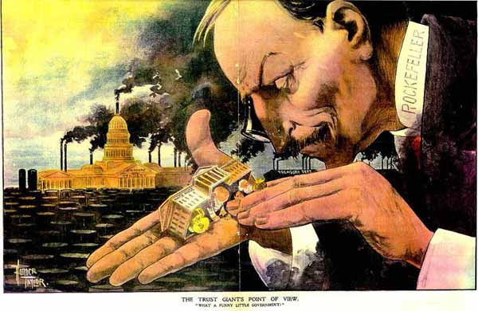
“The Trust Giant's Point of View. ‘What a funny little government.’" Source, Library of Congress - http://www.loc.gov/pictures/item/2007675471/
Use the political cartoon above to answer questions 1-5.

1. Which of the following was an attempted response by the federal government to the situation presented in the picture above?
  - Encouragement of prominent businessmen to run for political office
  - Passage of anti-trust legislation aimed at breaking up powerful businesses
  - A massive effort aimed at prohibiting pollution and environmental damage
  - Reorganization of oversight roles to prevent governmental corruption

2. What does the cartoon above assert about the relationship between government and business?
- Business and government work best when they are not involved with the concerns of the other
- Business owners often invited governmental oversight into the inter-workings of concerns
- Government policies and priorities provided little control over business and finance
- Business owners directly drove governmental policy through judicial influence

3. Based on what you can infer from the cartoon, what ways would workers have been affected by the relationship between laborers and business in the late 19th century?
- Workers could rely on governmental support in their negotiations with business leaders
- Business profits resulted in the improvement in working conditions in many industries
- Governmental regulations were made with the input of workers and business owners
- Workers relied on their collective efforts to present their concerns to business leaders

4. How would conservationists respond to the impact of industrial expansion based on the cartoon above?
- Conservationists were critical of governmental shortsightedness in limiting oil dependence
- Damage would only be momentary and eventually repaired with enlightened business practices
- Government regulations must be directed at limiting all development of natural spaces
- Many conservationists argued business profits would be increased with limitation of environmental damage

5. Which of the following social views supported the situation presented in the cartoon?
- Those that prospered most in the industrial economy were justified in the methods they chose to accumulate power
- The proper role of the government was a complete regulation of the industrial economy
- Workers should take an active role in the organization of business and management
- Political power spread across all social classes would prevent economic inequality

“… You shall not press down upon the brow of labor this crown of thorns, you shall not crucify mankind upon a cross of gold.” –William Jennings Bryan 1896

6. Which of the following is the above quote supporting?

a. The United States monetary policy would be best suited following the Gold Standard
b. A bimetalist monetary policy is the most equitable way to support all social classes
c. Through labor unions, atrocities of big business could be corrected .
d. Unrestricted emigrant labor threatened the moral and social identity of the United States

“But today we are raising more than we can consume. Today we are making more than we can use. Today our industrial society is congested; there are more workers than there is work; there is more capital than there is investment. We do not need more money—we need more circulation, more employment. Therefore, we must find new markets for our produce, new occupation for our capital, new work for our labor. . . .” — Senator Albert J. Beveridge, 1898

7. This statement above, from Senator Beveridge, provides a reason why political leaders of the late 1800s adopted the policy of
- imperialism
- isolationism
- protectionism
- collective security

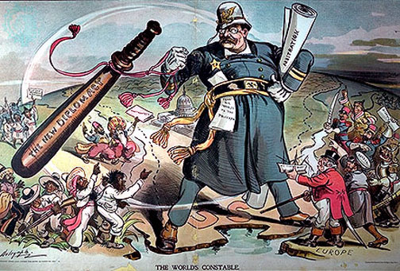

8. The political cartoon above supports which of the following perspectives on U.S. foreign policy under Presidents Taft and Roosevelt?
- The United States adopted a strong non-involvement policy in world affairs
- The U.S. government would not hesitate international intervention when American business and political interests were threatened
- The U.S. respected the sovereign rights of all people to determine their own political and economic futures
- The United States was dependent on European powers to govern political and economic affairs in the Western Hemisphere

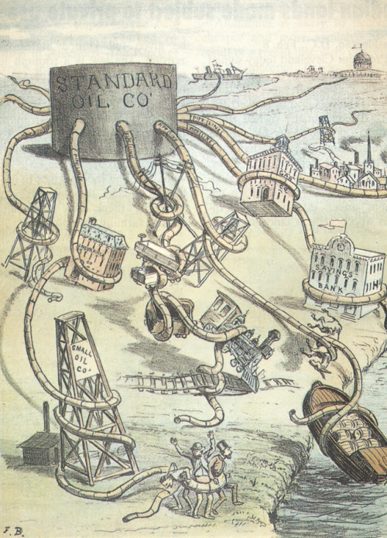

9. The cartoon above makes which of the following comments on late 19th century business practices?
- Companies relied on forming trusts and different types of integration to maximize profits and limit business challengers
- The best way to develop major industries was to encourage competition and keep a fair business environment for small companies
- Government regulations were strangling industry leaders like the Standard Oil Company.
- Foreign competition in the oil industry was very damaging to American companies.

10. After the Civil War, some influential Southerners—such as newspaper man Henry Grady—promoted the idea of a “New South.” Which of the following best describes their vision for the South in the late 19th century?
- An agricultural region consisting of small farms focused on growing food crops
- An industrial region whose economic mainstays would be the mining and smelting of minerals and metals
- An agricultural region of large plantations growing cotton, tobacco, and rice, worked by sharecroppers
- A mixed economy no longer primarily dependent on cash crops

