Pre-assessment 6.2

Name: _______________________________________________ Date: ____

Directions: Each of the questions or incomplete statements below is followed by five suggested answers or completions. Select the one that is best in each case and then fill in the corresponding circle on the answer sheet.

“Booming industries offered jobs to unskilled workers, like the Irish, Italian, Polish, and Hungarian peasants who poured into the cities in the late 1800s. These new immigrants also worked on the ever-expanding rail system, sometimes replacing Irish and Chinese laborers. American railroad companies advertised throughout Europe. They offered glowing descriptions of the Great Plains, hoping to sell land they received as government grants.”

History Alive! Pursuing American Ideals, High School Textbook, 2008

1. The influx of immigrants in the United States in the second half of the 19th century most directly led to which of the following?
A. The formation of cultural neighborhoods where people from the same country/region could support one another.
B. The establishment of political reform groups focused on expanding voting rights for immigrants..
C. The failure of the railroad..
D. The passage of the Sherman Anti-Trust Act.

2. Due to the immigration and nativism which increased during the later years of the 19th century,
A. The federal government passed the Chinese Exclusion Act of 1882.
B. Protestant evangelism rose to combat the rise of Catholicism in the cities.
C. The U.S. government established the Braceros program.
D. Resulted in the phenomenon known as urbanization.

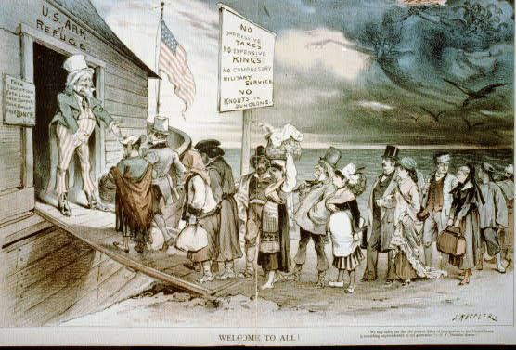

3. On the gangplank, the advertisement listed as “No Knouts and Dungeons” can be most related to which of the protections guaranteed to Americans in the Bill of Rights?
A. Right to Bear Arms
B. No oppressive taxes
C. Cruel and unusual punishment
D. Trial by jury

4. Which organization was set-up to transition immigrants to American assimilation?
A. Settlement Houses
B. NAACP
C. AFL-CIO
D. Tammany Hall

5. The promise of no oppressive taxes leading to greater freedom from government for capitalist ventures is known as:
A. Laissez-faire
B. Trusts
C. Monopolies
D. Manifest Destiny

“ As the early years at Hull House show, female participation in that area of reform grew out of a set of needs and values peculiar to middle class women in the late 19th century and early 20 century. Settlement workers did not set out to become reformers. They were rather women trying to fulfill existing social expectations for self-sacrificing female service while at the same time satisfying their need for public recognition, authority, and independence. In the process of attempting to weave together a life of service and professional accomplishment, they became reformers as the wider world defined them.”

- Robyn Muncy, historian, Creating a Female Dominion in American Reform, 1890-1935, published in 1991

- How did women impact the lives of immigrants during the Gilded Age?
  - Women petitioned for suffrage of incoming immigrants.
  - Women established settlement houses like the Hull House to help immigrants assimilate to American society and culture.
  - American women married immigrant men to help them achieve citizenship.
  - American women were competing for jobs also sought by immigrants, thus making it a more competitive job market.

- Women’s activism in settlement house work as described by Muncy had the most in common with which other social movement from an earlier period?
  - The Protestant evangelism of the mid-1700s.
  - The Daughters of Liberty in the decade leading up to the American Revolution.
  - The Abolitionist movement leading up to the Civil War.
  - The movement for universal suffrage for white men during the Jacksonian era.

