Period 6 Review (1865-1898)

http://ap.gilderlehrman.org/period/6

Important Events
American Civil War Ends (1865)
Transcontinental Railroad Comp. (1869)
Crédit Mobilier Scandal (1872)
Panic of 1873
Battle of Little Bighorn (1876)
Great Railroad Strike (1877)
Death of James Garfield (1881)
Chinese Exclusion Act (1882)
Haymarket Affair (1886)
Wounded Knee Massacre (1890)
Sherman Antitrust Act (1890)
Panic of 1893
Jackson’s Frontier Thesis (1893)
“Atlanta Compromise” (1895)
Plessy v. Ferguson (1896)
William McKinley Elected (1896)
Spanish-American War (1898)

Themes

Transition from a rural to an urban society!

Big Business
Rapid Industrial Development
Divide in Standard of Living
Reactions to the Growth of Business
Philanthropy
Big Cities
Urbanization
Immigration
Social Change
Big Changes
Changes in the West
Changes in the South
Changes in Government

LEQ: Growth of Big Business
Explain the major political and economic causes and consequences for the growth of big business in American society from 1870 to 1900

LEQ: The West
Evaluate the extent to which the West was a land of opportunity for various groups during the Gilded Age.

SAQ: Monopoly and Labor
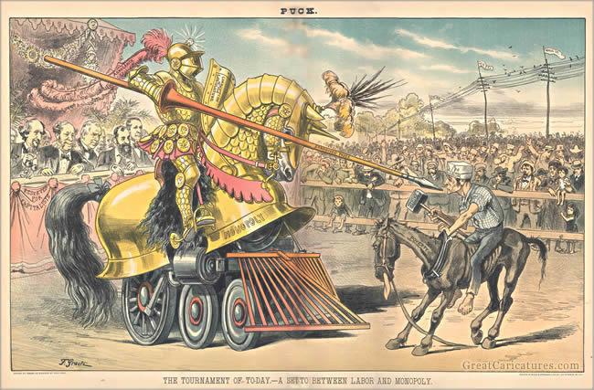

“Tournament of Today: A set-to between labor and monopoly” by Frederick Graetz, 1883
A) Explain the point of view of the political cartoon above.
B) Explain one specific historical event or concept that supports the cartoon above.
C) Explain one specific historical event or concept that resulted from the concept and ideas expressed in the image above.

SAQ: Growth of the Labor Mvt.
a. Briefly explain which of the following events most affected the organized labor movement at large in the late 19th century.
o Haymarket Riot
o Pullman Rail Strike
o Homestead Strike
b. Provide ONE example of an event or development from the event selected above to support your explanation.
c. Briefly explain why ONE of the other options had less of an effect on the organized labor movement.
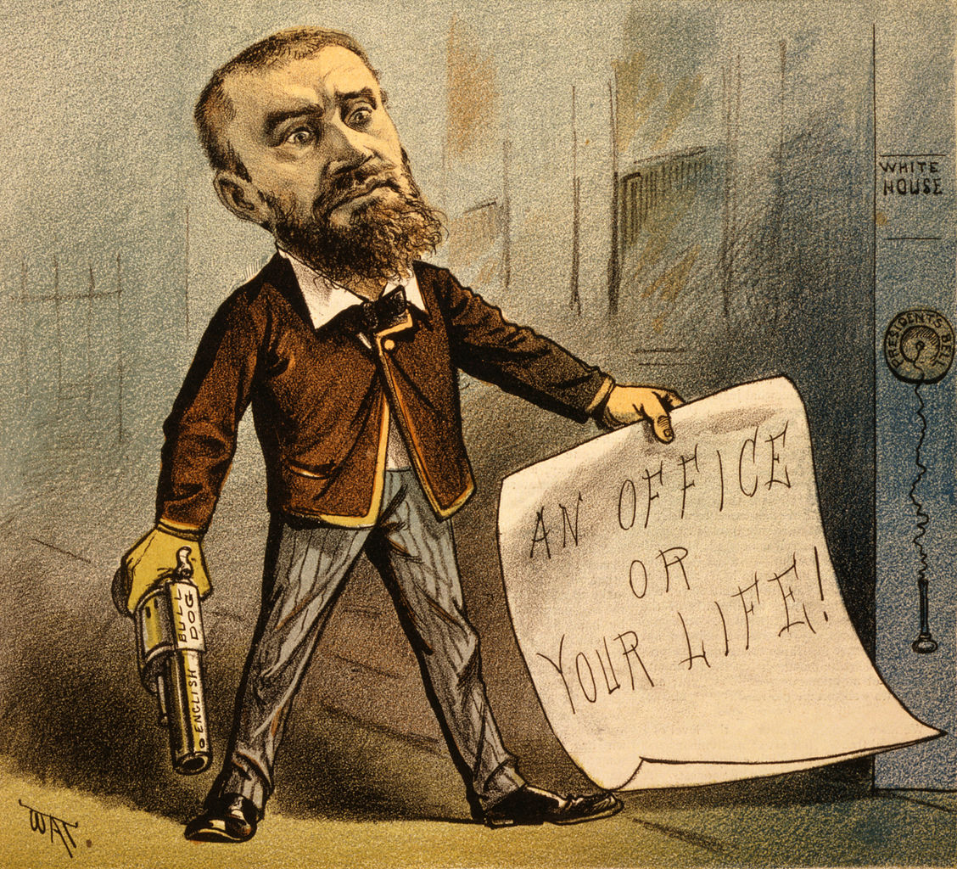

Big Business and Innovation
“New American System”
Government Subsidies
RR / Telegraph
Rise of Corporations with RR as Model
Transcontinental RR
Fuel Shifts
Whale Oil / Wood to Kerosene
Electricity by 1900
Petroleum / Natural Gas
Research and Development
Bell Telephone / Westinghouse
Vertical / Horizontal Integration
Women in the Workforce
Mass Marketing / Sears and Roebuck
Use of Immigrant Labor
Increase in the Standard of Living
Corporate Consolidations
“Robber Barons”—Carnegie, Vanderbilt, Rockefeller, J.P. Morgan, Gould

The Search for “New Markets”
Frederick Jackson Turner / Frontier Thesis
The Influence of Sea Power upon History
Open Door Policy
Spanish-American War

Labor in the Gilded Age
“Deskilling” of Labor
Great Railroad Strike of 1877
Knights of Labor
8 / 8 /8
Haymarket Square Riot
Homestead Strike
Pinkerton Detective Agency
Pullman Strike
Eugene V. Debs
Anarchism
Pullman Strike 1894
Blacklist
Closed Shop
American Federation of Labor
Samuel Gompers
Taylor and Scientific Management

Gilded Age Philosophy
Social Darwinism
Social Gospel
Gospel of Wealth
Laissez-Faire
Political Corruption
Political Machines
Boss Tweed / Tammany Hall
Thomas Nast
Patronage Jobs / Pendleton Act
James Garfield’s Assassination

Populist and Progressive Backlash
Panic of 1893
Interstate Commerce Commission
Sherman Anti-Trust Act
Coxey’s Army
Grange Movement
Populists
Greenback Party
Monetization of Silver
Panic of 1893
William Jennings Bryan
Beginnings of Progressivism
Lincoln Steffens
Ida Tarbell
Upton Sinclair
Jane Addams
Election of Wm. McKinley

The West in the Gilded Age
Homesteaders
Cattle Ranching
“The Open Range”
Cowboys
Dawes Severalty Act (1887)
Helen Hunt Jackson (Century of Dishonor)
Assimilation
Ghost Dancers / Wounded Knee
Barbed Wire / Mechanical Reaper
Gasoline Tractor

The South in the Gilded Age
Henry Grady / New South
“In the image of the North”
King Cotton / Monocrop Economy

Migration in the Gilded Age
Urbanization
Exodusters
Eastern Europeans
Chinese Exclusion Act 1882
Ethnic Clusters

Populist Platform
* Farmers began to see corporations, railroads, and banks as the enemy, and attempted to organize to improve purchasing power, effect political controls, and increase freedom of action
* High tariffs seen as hurting their purchasing power, while not protecting farmers from foreign agricultural competition
* Government policies benefitting banks, corporations, railroads – but not them! Grants built railroads, who then turned around and exploited farmers [their conspiracy theory was that railroads and banks constantly colluded to strip them of their profits]

Characteristics of Immigrant Assimilation
first generation tends to never fully assimilate; second generation tends to be ashamed of old culture and language, and to increase outward signs of assimilation [changing names, speaking only English, eating more “American” foods); third generation feels comfortable reaching back to celebrate past

Indian Wars
Indian Wars after the Civil War pitted the U.S. Cavalry against a number of Native American tribes:
Chief Red Cloud and Oglala Sioux, 1868; Custer’s Last Stand at Little Big Horn, 1873
Wounded Knee (1890)

Important Business Trends

A) Scientific management used by employers to promote efficiency; Frederick W. Taylor wanted to remove all thinking from work, replacing individual autonomy with expert advice; workers furiously resisted this.

B) Rockefeller drove out competition for Standard Oil and kerosene, using vertical and horizontal integration to set prices, increase profits, and destroy challengers. By 1890, Rockefeller controlled 95% of nation’s oil supply.

Advances for African Americans

* Plessy v. Ferguson created the infamous “separate but equal” doctrine and allowed the South to impose segregation and discrimination for the next seventy years through Jim Crow laws.
* South using prisons and lynchings to control blacks, and maintain white control of politics. The Redeemers!!
* Booker T. Washington chose an accommodationist path in his Atlanta Compromise, wherein he abandoned civil rights and protests In favor of economic advancement; founded Tuskegee Institute to train blacks in job skills (essentially, if blacks advanced in their value, civil rights would follow.
* W.E.B. DuBois would turn against Washington in the 1900s; why not go for civil rights now? They should be granted immediately.

