Period 5 Review (1844-1877)

http://ap.gilderlehrman.org/period/5

Important Events
Samuel Morse sends the 1st Telegraph (1844)
John O’Sullivan / Manifest Destiny (1845)
Mexican American War (1846)
Mormons Arrive in Utah (1847)
Compromise of 1850
Kansas Nebraska Act (1854)
Caining of Charles Sumner (1856)
Dred Scott Decision (1857)
Shots at Ft. Sumter (1861)
Emancipation Proclamation (1863)
Surrender at Appomattox (1865)
Impeachment of Johnson (1868)
Panic of 1873
Rutherford B. Hayes / Comp. of 1877

Themes
Expansion
---The United States was an increasingly global nation through trade and the actuation of Manifest Destiny through wars of expansion.
Crisis
---Political, Social, and Economic issues tore apart the American people.
---There was Conflict over national policy, action, and civil conflict.
---What were the political and social Changes during the Civil War?
Rebuilding
---Challenges faced the country in the aftermath of war. How were these faced in the political and social arenas?

LEQ: Westward Expansion
Evaluate the impact of the acquisition of new territories in the West had on American politics from 1840-1860.
LEQ: Reconstruction
Evaluate the extent to which Reconstruction was successful in improving the lives of African Americans in the South from 1865 to 1877.
SAQ: Expansion of Slavery
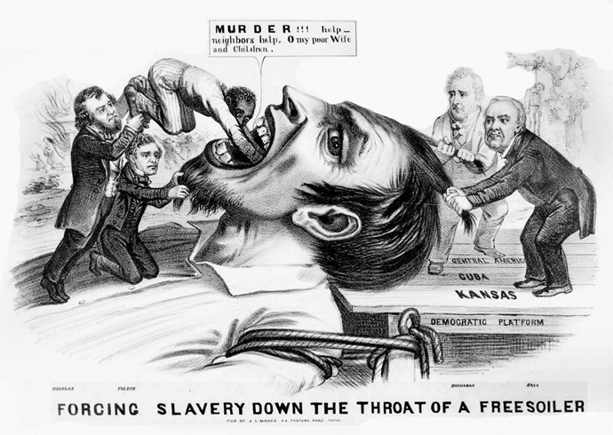

a. Briefly explain the point of view reflected in the cartoon above regarding the expansion of slavery in western territories.
b. Briefly explain ONE political development in the 1850’s that led to the issues portrayed in the image above.
c. Briefly explain ONE way in which the point of view you explained in part (a) was supported OR challenged in American culture in the 1850’s.

SAQ: Challenges to Reconstruction
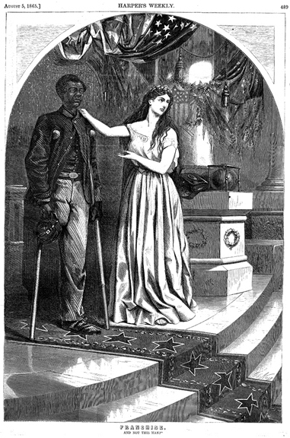

Thomas Nast, Franchise: And not this man?
Harper's Weekly, Aug. 5, 1865

A. Briefly explain the point of view expressed in the image with regard to one of the following:
-Radical Reconstruction
-Andrew Johnson’s Reconstruction Proposals
-Redemption / Home Rule

B. Provide ONE piece of evidence to support your answer in A.
C. Briefly explain how the issue you discussed in part A was resolved or challenged during Reconstruction (1865-1877).
Immigration and Interaction in the West
Oregon Trail
Missions in California
Mexican American War
Commodore Perry
Treaty of Kanagawa
Anti-Catholicism / Nativism
Know-Nothing Party
Homestead Act
Transcontinental Railroad
Domination of Hawaii
William Seward’s Follow
Chinese Immigration (Issues / Effects)
Battle of Little Bighorn
Destruction of the Bison

The Road to Civil War
Abolitionism
Slavery as a Positive Good
Paternalism
Biblical Justifications for Slavery
Free Soil Party / Dispute over Labor
Wilmot Proviso
Popular Sovereignty
Compromise of 1850 / Fugitive Slave Act Personal Liberty Laws
“Crime Against Kansas”
Caning of Charles Sumner
Uncle Tom’s Cabin
The Dred Scott Decision
Lincoln-Douglas Debates
James Buchanan

Civil War
Ordinances of Secession
Northern Advantages / Disadvantages
Southern Advantages / Disadvantages
Problems of Confederate Government
Alexander Stephen’s Cornerstone Speech
Anaconda Plan
Domestic Issues in the North
Unpopularity of the War
Draft Riots
Domestic Issues in the South
Effective Blockade
Inflation
Rebellious Slaves
Draft
“Rich man’s war, poor man’s fight”
Northern Economy booms
Emancipation Proclamation
U.S. Colored Troops
Lincoln’s Constant efforts at Reconciliation / Reunification (10% Plan / 2nd Inaugural)

Prosecution of the War:
---Shiloh / Vicksburg and U.S. Grant in the West (Completion of Anaconda Plan)
---Chancellorsville / Robert E. Lee vs. Slow Generals (McClellan) in the East
---Chattanooga / Atlanta / March to the Sea
---Surrender at Appomattox / Surrender of Joseph Johnston to Sherman in May
---Assassination of Abraham Lincoln

Reconstruction
13th / 14th / 15th Amendments
Presidency of Andrew Johnson
Impeachment
Tenure of Office Act
Radical Reconstruction
Reconstruction Act of 1867
Military Occupation of the South
Must Ratify 14th Amendment
(Characteristics of Black Reconstruction Governments and Southern Resistance)
Black Codes / Sharecropping
Freedman’s Bureaus

The Administration of U.S. Grant
Credit Mobilier Scandal
Whisky Ring Scandal
KKK / Force Act of 1871
Panic of 1873 and depression
Split in the Republican Party
Corrupt Election of 1876 (Tilden v. Hayes) 1877 Troops removed from the South
Redeemers (Southern Democrats)
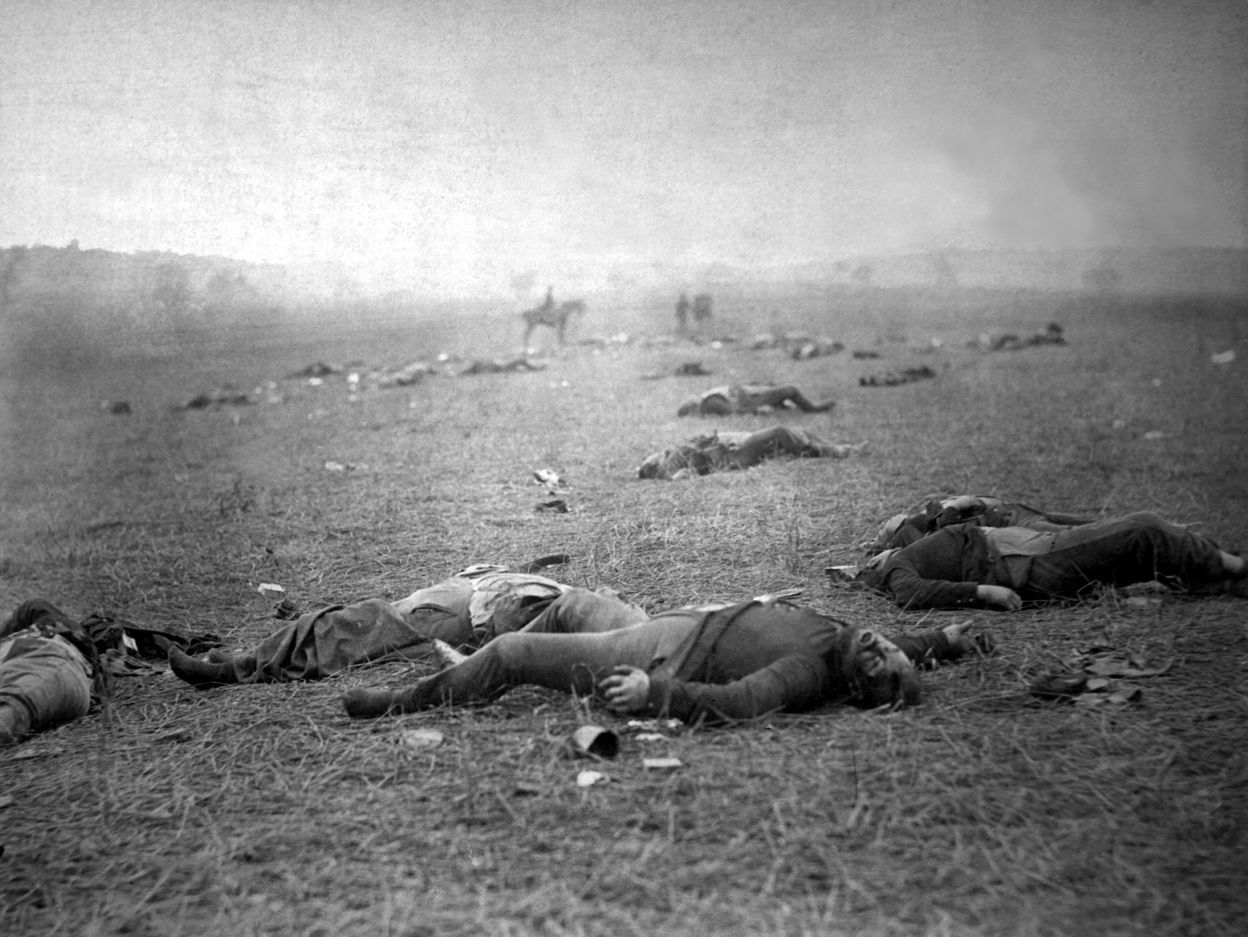

Harvest of Death, 1863 by Timothy O’Sullivan

