Period 4 Review (1800-1848)

http://ap.gilderlehrman.org/period/4

Important Events
Election of Jefferson (1800)
Louisiana Purchase (1803)
Embargo Act (1807)
War of 1812 Begins (1812)
Battle of New Orleans (1815)
Missouri Compromise (1820)
Election of Andrew Jackson (1828)
Texas Independence (1836)
Removal of the Cherokee (1836)
Seneca Falls Convention (1848)

Themes

“The Trials of Growing Up”

Growth
The Age of Nationalism
Land Purchases
Wars of Expansion

Identity
Developments in Technology, agriculture, and commerce
Distribution of Political Power
Distribution of Consumer Goods
Age of Reform

“Lone Ranger in a Larger World”
Expansion of Trade
The Age of Jackson
Development of Regional Identities
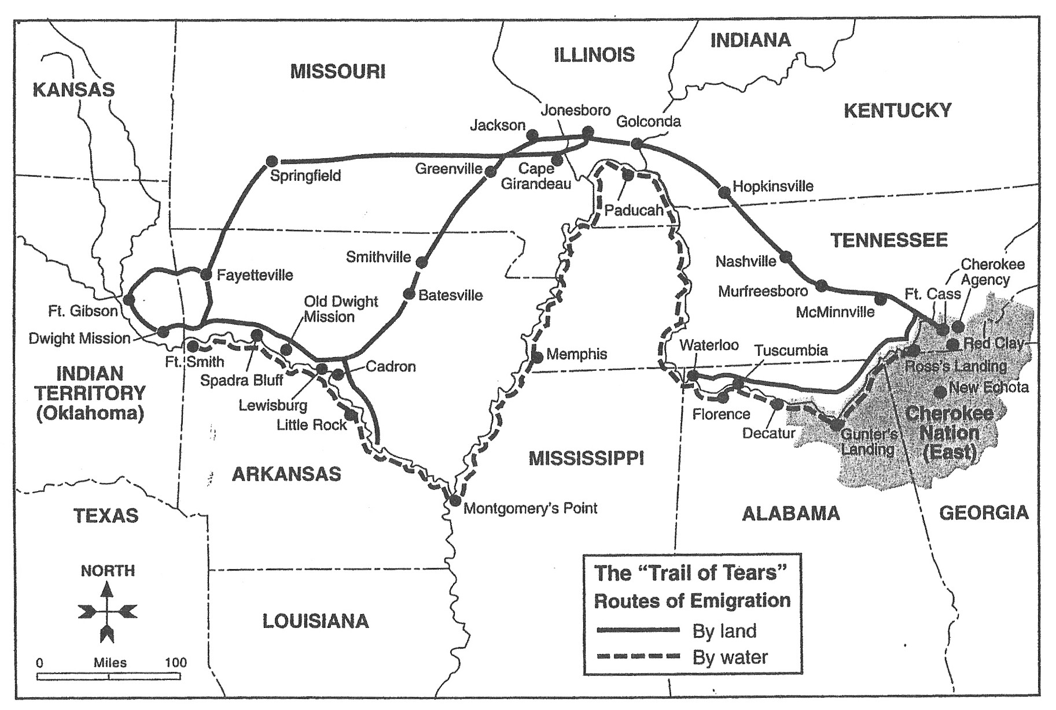

LEQ: Immigration

Compare and contrast the experiences of various European immigrant groups during the period 1830 to 1850.
LEQ: Sectional Tensions

Evaluate the impact of political compromise on sectional tensions in the period 1820 to 1860.
SAQ: New Democracy

a) Describe ONE example of political policy between 1824 and 1848 that illustrates the nation’s move toward a more participatory democracy.
b) Use at least ONE piece of evidence to support your explanation.
c) Briefly evaluate ONE limitation of this policy on the nation’s efforts to move to a more participatory democracy.

SAQ: Era of Good Feelings

a) Briefly explain ONE specific historical event which supports the time period between 1815 and 1825 as being the “Era of Good Feelings.”

b) Briefly explain ONE specific historical event which refutes the time period between 1815 and 1825 as being the “Era of Good Feelings.”

c) Briefly explain how western expansion either supports or refutes the idea of an “Era of Good Feelings.”

Jefferson’s Administration
Torn Between England / France
Quasi-War with France
Embargo Act
Non-intercourse Act
Mosquito Fleet

Madison’s Administration
War of 1812
War Hawks (Clay and Calhoun)
Hartford Convention

Supreme Court Cases in the Early National Period / John Marshall’s Jurisprudence
- Marbury v. Madison (1803)
- Dartmouth College v. Woodward (1819)
- McCulloch v. Maryland (1819)
- Gibbons v. Ogden (1824)

Monroe’s Administration
Monroe Doctrine
Mono-Party Rule
Sectionalism (Compromise of 1820)
Henry Clay and the American System
Impact of Telegraph / Railroads
Steam power (effects)
Importance Of Rivers in the Early Republic

J.Q. Adams / Jackson / Van Buren Administrations
Corrupt Bargain
Second Party System (Whigs vs. Democrats)
Andrew Jackson (“King Andrew”)
Veto of the National Bank
Issues with John C. Calhoun (Tariff of Abominations, Nullification)
Spoils System
Indian Removal
Panic of 1837 (“Martin van Ruin”)
“Gag Rule” in the House

James K. Polk’s Administration
Manifest Destiny
54’40” or Fight
California Republic
Texas Independence / Annexation
Mexican-American War
Spot Resolutions
Second Great Awakening
“Burned over District in New York”
Charles Grandison Finney
Mormons
Reforms / Reformers:
Temperance
Prisons / Asylums (Dorothea Dix)
Women’s Rights (Mott / Stanton)
Education (Horace Mann)
Utopians (Brook Farm / Oneida)
Transcendentalism (Emerson / Thoreau)
Emergence of Popular Culture (Minstrel Shows / Stephen C. Foster)
Hudson River School of Art (Thomas Cole)
Abolitionism
Frederick Douglass
Sojourner Truth
Harriet Beecher Stowe
William Lloyd Garrison
The Liberator
Nat Turner’s Rebellion
Denmark Vesey’s Revolt
American Colonization Society (Liberia)

Women’s Rights
Separate Spheres / “Cult of Domesticity”
Seneca Falls Convention
Declaration of Rights
Elizabeth Cady Stanton / Lucretia Mott

Important Ideas

Irish Immigration (to NYC / the Midwest)
German Immigration (to the Midwest / Wisconsin)

Westward Expansion of Slavery / Cotton / Soil Butchery

1st Industrial Revolution (Eli Whitney—Relationship Between North and South)

Market Revolution (Early Inventions / Erie Canal open up National Markets)

Loss of Property qualifications for voting (“Jacksonian Democracy”)

