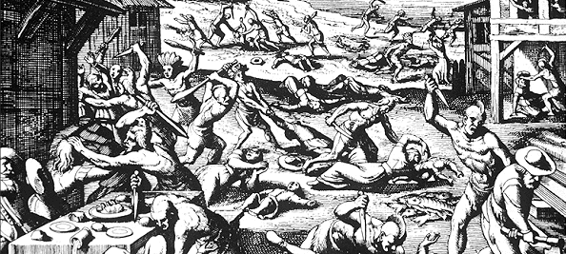
Period 2 Review (1607 – 1754)

http://ap.gilderlehrman.org/period/2

Important Events

Jamestown (1607)
African Slavery Introduced (1619)
Middle Passage
Pilgrims Land at Plymouth (1620)
Founding of New Amsterdam (1624)
Rhode Island (1630s)
King Phillips War (1675)
Pueblo Revolt (1680)
Salem Witch Hysteria (1692)

Themes

Gold
Diverse Imperial Goals
England (Atlantic Coast)
Spain (California, Southwest)
France (Louisiana, Canada)
Mercantilism
New World Labor Systems

God

Motivation (Religious Freedom)
City on a Hill
Sinners in the Hand of an Angry God
Salem Witch Trials
King Phillip’s War
First Great Awakening

Glory
How will it be achieved? At what cost?
--Each European Power
The Enlightenment

Stop at 4:30 (Addresses SAQ)

LEQ: Imperial Goals
Compare and contrast the European imperial goals in North America between 1580 and 1763.

SAQ (Powhatan War)

Powhatan Attack on Jamestown, 1622

Using your knowledge of American History and the image above, answer A, B, and C in complete sentences.

A) Briefly identify the POV of the image above.
B) Briefly explain one cause of the actions depicted above.
C) Briefly explain one long term consequence of the actions depicted above.

SAQ (Chesapeake vs. New England)

Answer (a), (b), and (c).

- Briefly explain ONE important similarity between the British colonies in the Chesapeake region and the British colonies in New England in the period from 1607 to 1754.
- Briefly explain ONE important difference between the British colonies in the Chesapeake region and the British colonies in New England in the period from 1607 to 1754.
- Briefly explain ONE factor that accounts for the difference that you indicated in (b).
SFI From the Time Period

French Fur Trade (Coeur de Bois, Intermarriage, Trapping)

Characteristics of Each of the 13 Colonies
New England Colonies (MA)
Middle Colonies (PA / NY)
Southern Colonies (VA / GA)

Religious Toleration in the Colonies, Maryland Act of Toleration (1649), Rhode Island

Virginia: Tobacco, Planter Class, Race Based Slavery, Indentured Servitude

Massachusetts: Theocracy, Religious Schooling, Puritans, Shipbuilding and Trading

New York / Pennsylvania: Religious Tolerance, Quakers, Friendly Indian Relations

South Carolina / Georgia: Slavery, Rice, Indigo, Cotton

Experiments in Self-Government: House of Burgesses, NE Town Hall Meetings

Mercantilism
Salutary Neglect
Triangle Trade
Beaver Wars and the Fur Trade / Iroquois League
John Smith / Pocahontas / Powhatan
Bacon’s Rebellion
King Phillip’s War
French and Indian (Seven Years) War
Pueblo Revolt
First Great Awakening
George Whitefield / Jonathan Edwards / “Sinners in the Hand of an Angry God”
Baptists / Methodists / Ivy League Schools
The Enlightenment / Deism / “Clockmaker God”
Locke / Rousseau / Montesquieu
Ben Franklin / “Poor Richards Almanac” / His Biography

“The Enlightenment and the Great Awakening both encourage rebellion against authority (how?)

Series of Slave Laws:
* 1662 Virginia law made slave status dependent on who mother was
* 1669 Virginia law made murder of a slave by owner not punishable by law
* 1675-76 Bacon’s Rebellion made African slavery the preferred labor force
* 1692 interracial sex made illegal (widely ignored by white males, but a major infraction for black males)
* 1705: Virginia made all Africans, by definition, slaves
* other laws passed: Africans couldn’t own guns, join militia, own white indentured servants, or be freed by religious conversion

Slave Resistance to Authority:
Stono Rebellion (1739), * passive resistance common as well, working slowly, or poorly, or “accidentally” breaking things
* theft or sabotage
* violence and murder
* running away, intermarry with Native Americans, or flee to towns and hiding as a free man

