Period 1 Review (1491 - 1607)

http://ap.gilderlehrman.org/period/1

Important Events
Europeans Discover the New World (1492)
Encomienda System Established (1512)
Conquest of the Aztecs (1519)
The Rise of the Atlantic Slave Trade (1520s)
De Las Casas / “Black Legend” (1550)
Tobacco Arrives in Europe (1555)
“Lost” Roanoke Colony Established (1585)
Francis Drake attacks St. Augustine (1586)
Virginia Colony Established (1607)

Themes

Contact
Sophistication of Pre-Columbian Civilizations

Commerce
Stratification of Society
The Columbian Exchange
Impact on the New World and the Old World

Competing Philosophies
Competing European Powers
Material Wealth of the New World
Protestants vs. Catholics
Slavery vs. Nonslavery

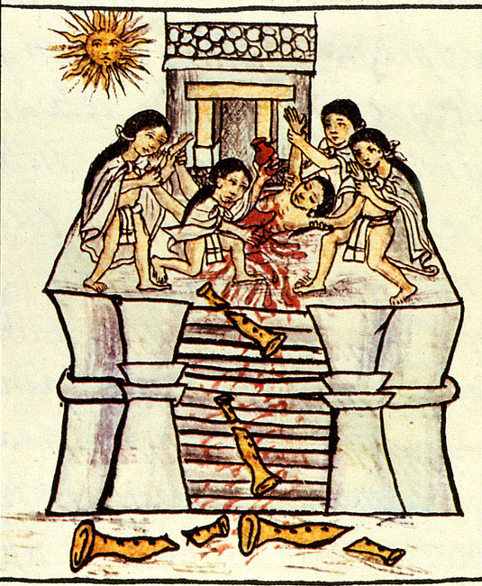

A depiction of human sacrifice from the Florentine Codex

SAQ: Columbian Exchange
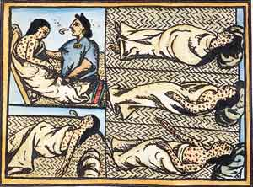

Drawing accompanying text in Book XII of the 16th-century Florentine Codex (compiled 1540–1585)
A. Explain the main point of the image in the context of ONE of the following:
· Exchange
· Migration
· European exploration and conquest of the Americas
B. Briefly describe ONE development that led to the main point you explained in part A. Use at least ONE piece of historical evidence to support your description.
C. What impact did the events depicted in the image above have on European conquest?

SAQ: Triangle Trade
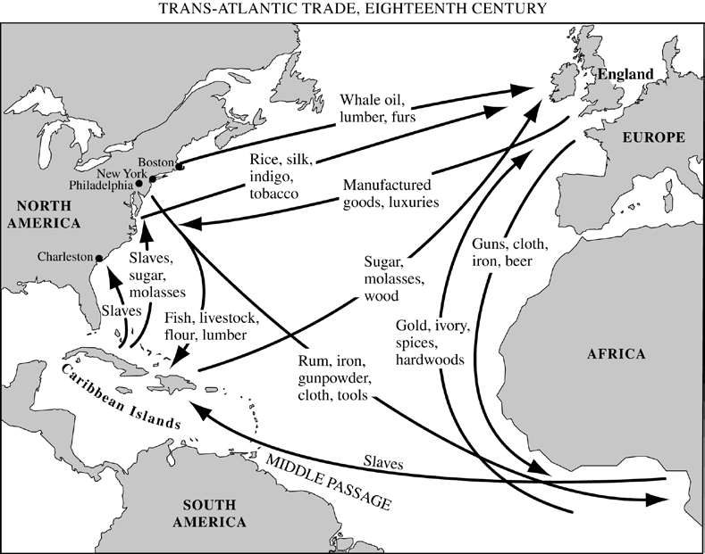

- Briefly explain ONE specific historical development that contributed to the emergence during the eighteenth century of the patterns depicted in the map.
- Briefly explain ONE specific historical effect that resulted from the patterns depicted in the map.
- Briefly explain ANOTHER specific historical effect that resulted from the patterns depicted in the map.
SFI From the Time Period

Three Sisters (Corn / Beans / Squash)
Spanish Introduction of the Horse
Impact on Plains Indians / Bison
Eastern Woodland Tribes
Northwest Indians
Pueblo Indians

Hernando Cortez and the domination of the Aztec Empire / Conquest
Columbus
Columbian Exchange
Plants, Animals, Diseases
Causes and Consequences
Population Explosion
Migration,
Colonization,
Development of Capitalism
Advances in Sailing Technology
Trans-Atlantic Slave Trade
Causes / Consequences
Joint-Stock Companies

Destruction of Native Flora Fauna by Disease (Cattle replace Bison, etc.)
Encomienda System (Slavery of the Indians)
De Las Casas v. Sepulveda
Black Legend
Spanish Caste System

Themes / Ideas (European Interactions)

* Europeans adopted the Three Sisters, particularly in New England and the Chesapeake, which allowed them to stay alive

* Native Americans adopted European technology, including knives, pots, and weapons

* Native Americans took advantage of the European desire for furs to gain European trade goods

*Iroquois Confederacy played the French and British off against each other for over a century
* Columbus seizing Native Americans and enslaving them, on the model of African slavery from Portugal

* Spanish forcibly assimilating Native Americans into Catholicism

* French Jesuits living among Natives to convert them gently

* Columbus thought Native Americans were Indians

* Moctezuma thought Cortés was the god Quetzlcoatl

* Native Americans didn’t understand the concept of owning the land; when they “sold” the land, they didn’t think it was permanent (Manhattan sold to the Dutch); Europeans insisted the sales were permanent

* Plains Indian fought by counting coup, while Europeans fought to kill

* Native American men hunted, while women often did the farming; Europeans appalled by this division of labor

* Europeans adopted the Three Sisters, particularly in New England and the Chesapeake, which allowed them to stay alive

* Native Americans adopted European technology, including knives, pots, and weapons

* Native Americans often learned European languages and converted to Christianity, particularly in the Spanish empire

