Period 1 Overview: 1491-1607
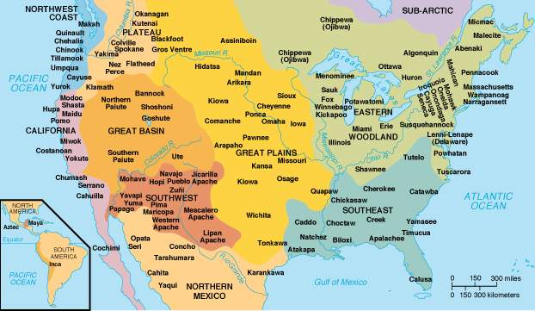
Overview Prior to the arrival of Christopher Columbus and other Europeans, the North American continent was home to diverse societies controlled by Native Americans. The first of these peoples arrived in the Americas at least 10,000 years ago, most likely by migrating across a land bridge called Beringia. These societies developed a wide variety of social, political, and economic structures based on interactions with the environment and each other. After 1492, the contact among the peoples of Europe, the Americas, and West Africa increasingly transformed the world, creating what is known as the “Columbian Exchange.” There were many positive and negative effects of this trans-Atlantic exchange, as well as worldview challenges. By 1607, the first permanent English settlement was established at Jamestown, Virginia, marking the beginning stages of a new nation.
Beginning = Pre­‐Columbian America, pre­‐Columbian Exchange, Native American life without European explorers/colonizers running around.

What do I need to know?

1. Native American life pre and post European contact.

a. Examples: Maize production, nomadic hunter/gathering, Pueblo, Northeast & Atlantic tribes like Algonquin, Powhatan, & Iroquois developed permanent villages, THEN horses, guns, disease, Columbian Exchange
2. European Patterns of Conquest/Colonization:

a. Spain: New World a source of precious metal and religious conversion, Native Americans = people to be converted to Christianity…settled central and South America, Caribbean
b. England: New World a source of precious metal and raw material– settler colonies – Native Americans = savages…settled Atlantic seacoast
c. France: New World = source for raw materials like fur – Natives = friends and trading partners….settled Canada and Ohio River Valley
3. Interactions between Natives and European people.

a. Examples: Encomienda System, Mestizos, Fur Traders, Columbian Exchange, Columbus vs. Las Casas, Trade, Smallpox

End of Period 1 = Founding of Jamestown in 1607. First Permanent English colony in theNew World.

Period Perspectives Contact between Europeans and the natives of America touched off a trans-Atlantic trade in animals, plants, and germs known as the Columbian Exchange. This trade altered the way people around the globe lived and thought. Within a hundred years, Spanish and Portuguese explorers and settlers developed colonies using natives and enslaved Africans for labor in agriculture and mining precious metals. Natives and Africans resisted oppression by maintaining elements of their cultures. The Spanish and the Portuguese were quickly followed to the Americas by the French and the Dutch, and later by the English.
Alternate Viewpoint Until the mid-20th century, most historians viewed Columbus and European explorers and settlers as great adventurers who founded colonies that developed into modern democracies. However, in recent years, historians have highlighted the vibrant and diverse native cultures that existed in the Americas before the arrival of Columbus, and how European diseases and violence destroyed so much of these cultures. The native population declined by 90 percent after the arrival of Europeans. To demonstrate this greater emphasis on native culture, historians often begin this period in 1491 rather than 1492.

