Period 6 Overview: 1865-1898
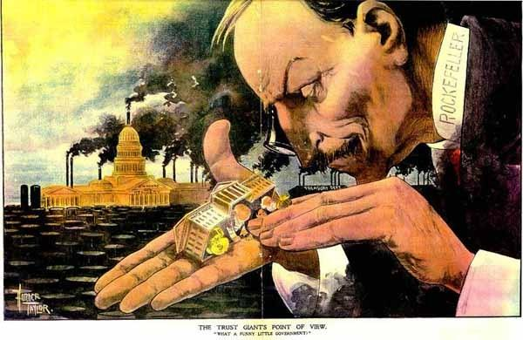
Overview The end of the Civil War in 1865 to the start of the Spanish-American War in 1898 serve as a convenient time frame for Period 6, which is focused on the fast-paced economic and urban development of the United States. During this period, the nation transformed from a rural agrarian to an increasingly urbanized society, resulting in significant social, economic, political, and environmental changes. Massive migrations and the emergence of an industrial culture led to greater opportunities as well as restrictions and prejudices towards immigrants, minorities, and women. New political, cultural, and intellectual movements attempted to address growing economic disparities. As a result, the United States emerged as the largest economy in the world and a potential international power.

Beginning = This period begins with the Second Movement West. Americans settled the prairie & fought Native Americans. Capitalism trumped democracy as “Captains of Industry” like Rockefeller, Morgan, and Carnegie fought for control of the nation’s business. This led to the Populist backlash against political corruption and social and economic inequities during the Gilded Age.

What do I need to know?
1. How the government encouraged westward expansion and eventually destroyed Native American culture in the prairie
a. Examples: Homestead Act, Dawes Act, Battles of Little Bighorn and Wounded Knee (End of Native American resistance 1890), assimilation/annihilation of Native Americans
b. Land Grants from the government (Homestead Act) used by railroads

2. The rise of capitalism & big business permanently transformed America from a farming (agrarian) society into an industrial powerhouse and brought many problems economically, socially, politically, and environmentally
a. Examples:
i. Economic: Bessemer Process, monopolies & trusts, laissez­‐ faire economics, Sherman Anti­‐Trust Act, bonanza mining and farming
ii. Social: Low wages led to urban slums/dumbbell tenements increased crime and poverty, Settlement House Movement (Jane Addams), immigration increased (New Immigrants)
iii. Political: Political Machines (Tammany Hall/Boss Tweed), control of local politicians by big business
iv. Environment: Placer mining changed to industrial strip mining, destruction of natural resources, oil boom towns, conservation movements began (Sierra Club)
v. Farmers: The Grange and People’s Party…becomes Populist Party…liked silver and inflationary policies, income tax, regulation of railroads

3. Workers UNIONIZED during this time period and fought capitalists for a better standard of living
a. Examples:
i. Unions: Knights of Labor (too disorganized), IWW (“Wobblies” – too radical, American Federation of Labor (Samuel Gompers) used collective bargaining and the strike.
ii. Labor Unions Struggles: Skilled vs. unskilled workers, immigrants, African Americans, hostility from employers and government, court injunctions (In re Debs)
iii. Major Strikes/Events: Homestead Strike (Carnegie Steel), Haymarket (unions painted as radical), Pullman Strike (effect of Depression of 1893) all ended with government intervention on behalf of business against labor

4. How various groups struggled for equality
a. African Americans: Post Civil War “window of sunshine” closed as southern states were redeemed, Jim Crow Laws, Black Codes, Plessy vs. Ferguson legalized Jim Crow, lynching
b. Immigrants: “New” immigrants arrived from Eastern Europe through Ellis Island, Catholic & Jewish immigration, Asian immigration increases in the West, Angel Island, Chinese Exclusion Act, return of nativism
End = 1898 Spanish/American War and American imperialism

Period Perspectives Historians have labeled the period in several ways. For some, it is the "Second Industrial Revolution," which introduced the wonders of electric powered technologies, petroleum energy, and the first industrial laboratories. Others called it, the "Railroad Era," which produced a continental network of railroads that could move the products of the new large-scale industries. For some it is the "Last Frontier," which witnessed the settlement of lands between the Mississippi River and the Pacific Ocean and the end of the "Indian Wars." However, the characterization that has most endured is the "Gilded Age," a time during which the "Captains of Industry" controlled large corporations, created great fortunes, and dominated politics, while the problems of farmlands and burgeoning cities festered under the surface.
During the late 1800s, waves of "new" immigrants also added to the growth of the nation, while reformers, labor unions, farmer organizations, and a growing middle class began to challenge economic, political, and cultural institutions.
Alternate View One limitation to ending the period in 1898 is that it frag­ments the early reform movements that started in the late 1800s, but produce few results until the Progressive era from 1900 to 1917.

