Use the map below to answer questions 1-3.
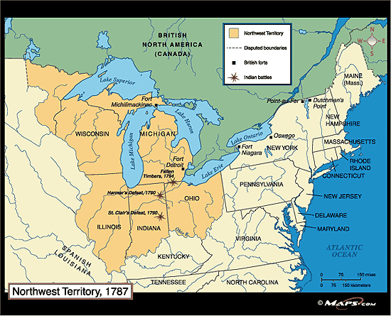

- The Northwest Ordinance of 1787 is most similar to the Missouri Compromise of 1820 in that both sought to address the issue of
- women’s rights.
- Native American assimilation.
- Expansion of slavery as new states are created.
- foreign alliances.

- Which of the following most immediately resulted from the passage of the Northwest Ordinance?
- increased western settlement past the Appalachian Mountains.
- development of a transcontinental railroad.
- relocation of Native Americans to reservations.
- Great Britain’s abandonment of forts in the northwest.

- The banning of slavery in the Northwest Territory most resembles the goals of what future political party?
- Progressive Party.
- Free-Soil Party.
- Federalist Party.
- Socialist Party.

Use the following quote to answer questions 4-6.
“a national debt, if it is not excessive, will be to us a national blessing”
Alexander Hamilton, 1781
- Hamilton’s quote was manifested in his later desire to
- Create a national bank.
- Pay off all state debts at par.
- Establish a uniform currency system.
- Place excise taxes on certain products

- Which of the following people would have been most opposed to Hamilton’s opinion?
- George Washington
- John Jay
- Thomas Jefferson
- Robert Morris

- Which of the following developments demonstrate the strongest continuity with Hamilton’s ideas?
- the Omaha Platform of the Populist Party.
- deficit spending during the New Deal.
- passage of the Federal Reserve Act.
- Jackson’s removal of deposits from the National Bank.

Use the following excerpt to answer questions 7-8.
“If any citizen of the United States, or any other white person or persons, shall presume to settle upon the lands now relinquished by the United States, such citizen or other person shall be out of the protection of the United States; and the Indian tribe, on whose land the settlement shall be made, may drive off the settler, or punish him in such manner as they shall think fit; and because such settlements, made without the consent of the United States, will be injurious to them as well as to the Indians, the United States shall be at liberty to break them up, and remove and punish the settlers as they shall think proper, and so effect that protection of the Indian lands herein before stipulated…”
Excerpt from the Treaty of Greenville, 1795

- Which of the following led to the creation of the treaty?
- Increased White American expansion into the NW Territory.
- Continuing post-war border disputes with Great Britain.
- Questions over territorial sovereignty between Spain and Native American tribes.
- Division of power between states and the federal government.
- Which of the following political actions demonstrates the strongest change from the Treaty of Greenville?
- Indian Removal Act
- Treaty of Paris (1898)
- Hay-Bunau-Varilla Treaty
- Dawes Severalty Act

Use the following excerpt to answer questions 9-10.
In 1783, Nancy Shippen wrote a journal entry, outlining goals for her daughter’s education.
1st Study well her constitution and genius
2nd Follow nature and proceed patiently
3rd Suffer not servants to terrify her with stories of ghosts and goblins
4th Give her a fine pleasing idea of good, and an ugly frightful one of evil
5th Keep her to a good and natural regimen of diet
6th Observe strictly the little seeds of reason in her, and cultivate the first appearance of it diligently.

Excerpts from the journal of Nancy Shippen (1783)

- The above excerpt best reflects the ideas of
- Popular Sovereignty
- Woman Suffrage
- Republican Motherhood
- Abolition

- Ideas from the above excerpt were later expressed in
- The Bill of Rights
- Uncle Tom’s Cabin
- The McGuffey Reader
- The Declaration of Sentiments

