Pre-Assessment Module: 7.1 II
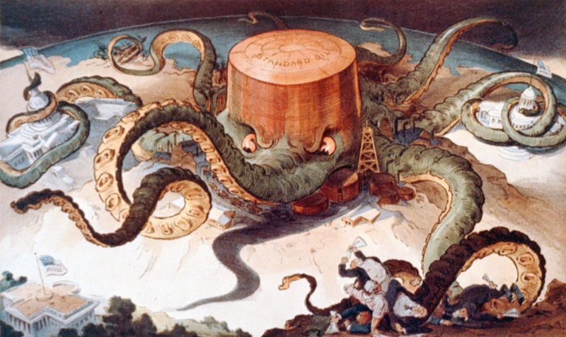
Based on political cartoon “The Standard Oil Octopus” and article “The Spoilsmen: An Age of Cynicism” from The American Political Tradition.
- The creation of trusts and monopolies during the laissez-faire Gilded Age led to the Progressive sentiment that
  - the titans of industry worked hand in hand with politicians
  - big business benefited the lower economic classes since more people could be hired than ever before
  - the federal government should take greater control over commerce and the regulation of the general economy
  - the economic system of the United States was growing and had such far reaching, even international, power

- This illustration exemplifies the popularity of which of the following economic innovations?
- the emergence of the philosophy that wages should be strictly determined by the market place not by any other false or artificial factor.
- Carnegie’s and Rockefeller’s support of the Gospel of Wealth
- the development of horizontal and vertical integration as well as interlocking directorates
- the implementation of Taylorism to make labor and production more efficient and profitable.

3) The development of which of the following social movements demonstrates the strongest comparison with the idea expressed in the above illustration?
- the creation of the Populist Party
- the development of the Occupy Wall Street movement
- the development of social justice
- the consolidation of national interest in the expansion of suffrage for women.

4) Which of the following events during the Gilded Age led to Wilson’s support of the Federal Reserve Act in 1913?
- the unregulated formation of monopolies and trusts
- banks were too much influenced by stock speculators on Wall Street
- the increase in nativism and anti-immigrant sentiment
- the unexpected drop in stock values that led to the Great Depression.

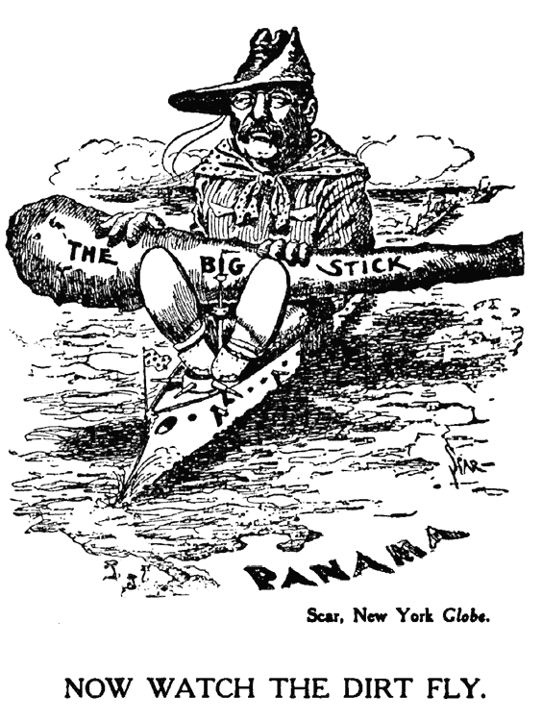

- This political cartoon most clearly depicts which of the following historical developments in the late 19th and early twentieth centuries?
  - imperialism
  - industrialization
  - isolationism
  - immigration

- The cartoon most directly reflects a growing belief that:
- America should pursue military involvement in the Western hemisphere
- Isolationism would improve the American economy
- America should spread democracy to other countries
- the American government should pursue nation building

- The cartoon above represents a continuation of what earlier 19th century movement
- Manifest Destiny
- Populism
- Social Gospel
- Nativism

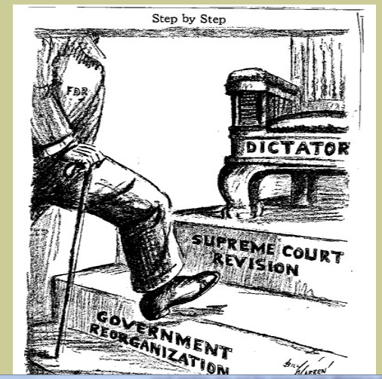

Step By Step by Billy Warren
The Buffalo Evening News, February 11, 1937

8} The ideas in the cartoon above most directly reflects which of the following continuities in American History?
  - growth of the power of the executive branch
  - the role of government in providing relief to the poor
  - the shift from a republic to a totalitarian regime
  - the breakdown of checks and balances
- Which of the following is the best example of the continuity expressed in the cartoon?
  - Truman’s Fair Deal
  - Andrew Jackson vetoing the Bank of the U.S
  - Kennedy’s New Frontier
  - Johnson’s Great Society and War on Poverty

- The point of view expressed in the cartoon is in response to what historical event?
- FDR’s wartime economy policies
- Implementation of the Social Security Act
- The passage of the National Labors Act (Wagner Act)
- The proposal of court packing

