Module (7.1)

Pre-Assessment | Complete formative assessment quiz for 7.1
Introductory Activity | Movie clip: Cinderella Man trailer  https://www.youtube.com/watch?v=VZzqbaYPV6E  Highlights troubles of the Great Depression.  Discussion Questions:  http://www.law.unc.edu/documents/poverty/curriculum/resources-cinderellaman-discussionquestions.pdf
Reading Activity | Franklin D. Roosevelt, Nominating Address, July 2, 1932  Chairman Walsh, my friends of the Democratic National Convention of 1932:  ...As we enter this new battle, let us keep always present with us some of the ideals of the Party: The fact that the Democratic Party by tradition and by the continuing logic of history, past and present, is the bearer of liberalism and of progress and at the same time of safety to our institutions. And if this appeal fails, remember well, my friends, that a resentment against the failure of Republican leadership--and note well that in this campaign I shall not use the word "Republican Party," but I shall use, day in and day out, the words, "Republican leadership"--the failure of Republican leaders to solve our troubles may degenerate into unreasoning radicalism.  The great social phenomenon of this depression, unlike others before it, is that it has produced but a few of the disorderly manifestations that too often attend upon such times.  Wild radicalism has made few converts, and the greatest tribute that I can pay to my countrymen is that in these days of crushing want there persists an orderly and hopeful spirit on the part of the millions of our people who have suffered so much. To fail to offer them a new chance is not only to betray their hopes but to misunderstand their patience.  To meet by reaction that danger of radicalism is to invite disaster. Reaction is no barrier to the radical. It is a challenge, a provocation. The way to meet that danger is to offer a workable program of reconstruction, and the party to offer it is the party with clean hands. This, and this only, is a proper protection against blind reaction on the one hand and an improvised, hit-or-miss, irresponsible opportunism on the other.  There are two ways of viewing the Government's duty in matters affecting economic and social life. The first sees to it that a favored few are helped and hopes that some of their prosperity will leak through, sift through, to labor, to the farmer, to the small business man. That theory belongs to the party of Toryism, and I had hoped that most of the Tories left this country in 1776.  Discussion Questions  - Students will use an APPARTS sheet to analyze FDR’s 1932 speech. Student analysis will be scored using an APPARTS rubric.
Student Product | Key Concept 7.1 Module Group Activity  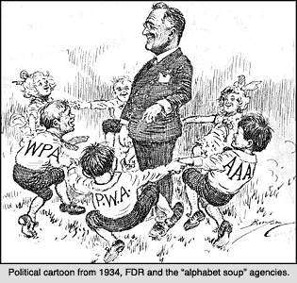  - Students will complete a HAPP activity.  - Students will connect the cartoon a historical theme and explain why they have chosen that theme.

