Module 4.3

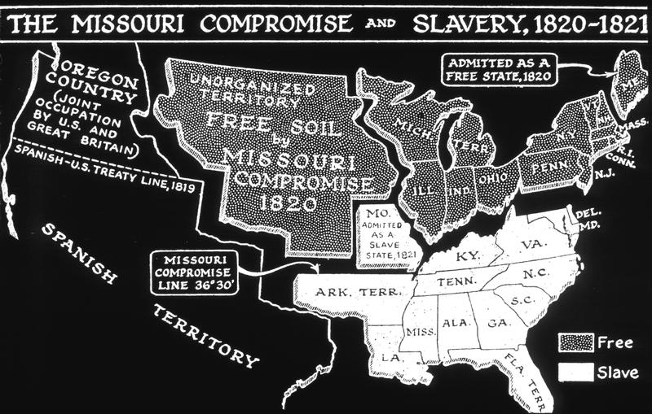

Key Concept 4.3 U.S. interest in increasing foreign trade, expanding its national borders, and isolating itself from European conflicts shaped the nation’s foreign policy and spurred government and private initiatives.

Throughout the first half of the nineteenth century, US policy makers sought to expand American power both internally and abroad. Many American citizens supported this expansion in hopes of expanding their markets and opportunities to exploit land resources west of the Mississippi River. Many other Americans dissented from these plans and felt that American expansion threatened to provoke internal conflicts and erode the universal human rights that were described in the Declaration of Independance.
As expansion continued westward, the debate over the fate of enslaved Americans became increasingly heated. American policy makers and citizens debated the expansion of slavery into new a territory, it would become a slave state with the corresponding power in Congress. Compromises over the expansion of slavery proved successful in the first half of the nineteenth century but became increasingly difficult toward the middle of the century.

Pre-Assessment | Complete formative assessment quiz for 4.3 (see Formative Assessment 4.3)
Reading Activity | Read the following excerpt of the Missouri Compromise of 1820:  “An Act to authorize the people of the Missouri territory to form a constitution and state government, and for the admission of such state into the Union on an equal footing with the original states, and to prohibit slavery in certain territories.  Be it enacted by the Senate and House of Representatives of the United States of America, in Congress assembled, That the inhabitants of that portion of the Missouri territory included within the boundaries herein after designated, be, and they are hereby, authorized to form for themselves a constitution and state government, and to assume such name as they shall deem proper; and the said state, when formed, shall be admitted into the Union, upon an equal footing with the original states, in all respects whatsoever.  SEC.2. And be it further enacted, That the said state shall consist of all the territory included within the following boundaries, to wit: Beginning in the middle of the Mississippi river, on the parallel of thirty-six degrees of north latitude; thence west, along that parallel of latitude, to the St. Francois river; thence up, and following the course of that river, in the middle of the main channel thereof, to the parallel of latitude of thirty-six degrees and thirty minutes; thence west, along the same, to a point where the said parallel is intersected  by a meridian line passing through the middle of the mouth of the Kansas river, where the same empties into the Missouri river, thence, from the point aforesaid north, along the said meridian line, to the intersection of the parallel of latitude which passes through the rapids of the river Des Moines, making the said line to correspond with the Indian boundary line; thence east, from the point of intersection last aforesaid, along the said parallel of latitude, to the middle of the channel of the main fork of the said river Des Moines; thence down arid along the middle of the main channel of the said river Des Moines, to the mouth of the same, where it empties into the Mississippi river; thence, due east, to the middle of the main channel of the Mississippi river; thence down, and following the  course of the Mississippi river, in the middle of the main channel thereof, to the place of beginning : Provided, The said state shall ratify the boundaries aforesaid . And provided also, That the said state shall have concurrent jurisdiction on the river Mississippi, and every other river bordering on the said state so far as the said rivers shall form a common boundary to the said state; and any other state or states, now or hereafter to be formed and bounded by the same, such rivers to be common to both; and that the river Mississippi, and the navigable rivers and waters leading into the same, shall be common highways, and forever free, as well to the inhabitants of the said state as to other citizens of the United States, without any tax, duty impost, or toll, therefor, imposed by the said state.  APPROVED, March 6, 1820.”  -Excerpt from the Missouri Compromise (1820)  Read the following excerpt of Uncle Tom’s Cabin  "And now," said Legree, "come here, you Tom. You see, I telled ye I didn't buy ye jest for the common work; I mean to promote ye, and make a driver of ye; and to-night ye may jest as well begin to get yer hand in. Now, ye jest take this yer gal and flog her; ye've seen enough on't to know how." I beg Mas'r's pardon," said Tom; "hopes Mas'r won't set me at that. It's what I an't used to, -- never did, -- and can't do, no way possible." "Ye'll larn a pretty smart chance of things ye never did know, before I've done with ye!" said Legree, taking up a cowhide, and striking Tom a heavy blow cross the cheek, and following up the infliction by a shower of blows. "There!" he said, as he stopped to rest; "now, will ye tell me ye can't do it?" "Yes, Mas'r," said Tom, putting up his hand, to wipe the blood, that trickled down his face. "I'm willin' to work, night and day, and work while there's life and breath in me; but this yer thing I can't feel it right to do; -- and, Mas'r, I never shall do it, -- never!" Tom had a remarkably smooth, soft voice, and a habitually respectful manner, that had given Legree an idea that he would be cowardly, and easily subdued. When he spoke these last words, a thrill of amazement went through every one; the poor woman clasped her hands, and said, "O Lord!" and every one involuntarily looked at each other and drew in their breath, as if to prepare for the storm that was about to burst. Legree looked stupefied and confounded; but at last burst forth, -- "What! ye blasted black beast! tell me ye don't think it right to do what I tell ye! What have any of you cussed cattle to do with thinking what's right? I'll put a stop to it! Why, what do ye think ye are? May be ye think ye'r a gentleman master, Tom, to be a telling your master what's right, and what ain't! So you pretend it's wrong to flog the gal!" "I think so, Mas'r," said Tom; "the poor crittur's sick and feeble; 't would be downright cruel, and it's what I never will do, nor begin to. Mas'r, if you mean to kill me, kill me; but, as to my raising my hand agin any one here, I never shall, -- I'll die first!" Tom spoke in a mild voice, but with a decision that could not be mistaken. Legree shook with anger; his greenish eyes glared fiercely, and his very whiskers seemed to curl with passion; but, like some ferocious beast, that plays with its victim before he devours it, he kept back his strong impulse to proceed to immediate violence, and broke out into bitter raillery. "Well, here's a pious dog, at last, let down among us sinners! -- a saint, a gentleman, and no less, to talk to us sinners about our sins! Powerful holy critter, he must be! Here, you rascal, you make believe to be so pious, -- didn't you never hear, out of yer Bible, 'Servants, obey yer masters'? An't I yer master? Didn't I pay down twelve hundred dollars, cash, for all there is inside yer old cussed black shell? An't yer mine, now, body and soul?" he said, giving Tom a violent kick with his heavy boot; "tell me!" In the very depth of physical suffering, bowed by brutal oppression, this question shot a gleam of joy and triumph through Tom's soul. He suddenly stretched himself up, and, looking earnestly to heaven, while the tears and blood that flowed down his face mingled, he exclaimed, "No! no! no! my soul an't yours, Mas'r! You haven't bought it, -- ye can't buy it! It's been bought and paid for, by one that is able to keep it; -- no matter, no matter, you can't harm me!" "I can't!" said Legree, with a sneer; "we'll see, -- we'll see! Here, Sambo, Quimbo, give this dog such a breakin' in as he won't get over, this month!" The two gigantic negroes that now laid hold of Tom, with fiendish exultation in their faces, might have formed no unapt personification of powers of darkness. The poor woman screamed with apprehension, and all rose, as by a general impulse, while they dragged him unresisting from the place.  -excerpt from Uncle Tom’s Cabin, Harriet Beecher Stowe  Read “John Brown: Father of American Terrorism” by Ken Chowder  http://web.bend.k12.or.us/brian.crum/Crum/APUSH_files/The%20Father%20of%20American%20Terrorism-%20John%20Brown.pdf
Writing Activity | Short Answer Question:  U.S. historians have proposed various events to mark the turning point in the lead up to the American Civil War  A.) Choose ONE of the events listed below, and explain why your choice best represents the turning point in the events lead up to the American Civil War. Provide at least ONE piece of evidence to support your explanation.  1820-Missouri Compromise  1852-publication of Uncle Tom’s Cabin  1859-John Brown’s Raid on Harpers Ferry  B.) Contrast your choice against ONE of the other options, demonstrating why that option is not as good as your choice.
Student Product | The 1820 Missouri Compromise created a truce over the issue of slavery that gradually broke down as confrontations over slavery became increasingly bitter.  Six Degrees of Separation: (Periodization, Continuity and Change)  1820-Missouri Compromise  1852-publication of Uncle Tom’s Cabin  1859-John Brown’s Raid on Harpers Ferry  - Divide students into small groups.  - Have each group create chart of the above events (T-chart, bubble map)  - Have students work in groups to brainstorm ideas on ways in which their assigned event could and could not be seen as a first step leading to the American Civil War.  - Create a periodization chart. Provide examples of significant events before and prior to these three events that include the Thematic Learning Objectives - Peopling, Politics and Power, America in the World, Identity, Environment and Geography.  - Explain why the Missouri Compromise of 1820 directly led to escalation of the American Civil War.

For more help visit http://ap.gilderlehrman.org/period/4

