Key Concept 2.2
“for having protected, favored, and emboldened the Indians against His Majesty’s loyal subjects, never contriving, requiring, or appointing any due or proper means of satisfaction for their many invasions, robberies, and murders committed upon us.”
Nathaniel Bacon, describing the faults of Governor Berkeley, 1676
“I have lived thirty-four years amongst you [Virginians], as uncorrupt and diligent as ever [a] Governor was, [while] Bacon is a man of two years amongst you…I will take counsel of wiser men than myself, but Mr. Bacon has none about him but the lowest of the people.”
Governor William Berkeley, responding to “Bacon’s Manifesto,” 1676
- Which of the following developments demonstrated the strongest continuity with the attitudes expressed by Bacon?
- The growth of the British-American system of slavery
- The increasing anger of British colonists in the backcountry or western parts of the colonies
- The spread of Enlightenment ideas
- Britain’s increasingly strict control of the colonies

- The differing opinions of Bacon and Berkeley are an example of which of the following divisions in the British colonies?
- An increasing class divide between wealthier and poorer colonists
- An increasing economic divide between northern and southern colonies
- The growth of two different schools of thought on how civilized American Indians were
- An increasing religious divide between the Virginia Anglicans and non-Anglican immigrants

- Berkeley’s reference to “the lowest of the people” most likely includes which of the following groups?
- American Indians
- Slaves and indentured servants
- Plantation owners
- Non-Anglicans

Questions 4-6 refer to the graph below.
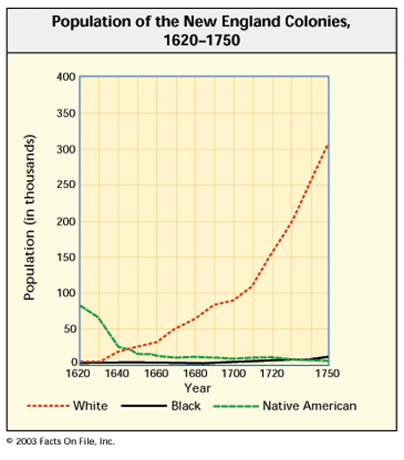
- Which of the following was a significant cause of the Native American population changes depicted in the graph?
- European diseases such as smallpox
- The trade of guns from Europeans to American Indians
- Wars between Europeans and American Indians and between different tribes of American Indians
- All of the above

- Which of the following was a direct effect of the white population changes depicted in the graph?
- Increased environmental pressure on the land
- Increased immigration and better health among colonists
- The importation of significantly greater numbers of African slaves to New England
- A growing independence movement against the British government

- The main trends shown in the graph were most directly associated with which of the following processes occurring in New England at the time?
- The gradual expansion of British colonists’ landholdings
- The increasing importation of guns and other metal goods
- The spread of Enlightenment ideas
- The development and growth of cash crop agriculture
A brief and plain scheme how the English colonies in the North parts of America,--viz., Boston, Connecticut, Rhode Island, New York, New Jerseys, Pennsylvania, Maryland, Virginia, and Carolina,--may be made more useful to the crown and one another's peace and safety with an universal concurrence.
That the several colonies before mentioned do meet once a year, and oftener if need be during the war, and at least once in two years in times of peace, by their stated and appointed deputies, to debate and resolve of such measures as are most advisable for their better understanding and the public tranquility and safety.
--William Penn, 1697
7. Which of the following developments is best represented in the above excerpt?
- Development of the Dominion of New England
- England’s Glorious Revolution
- Creation of the Iroquois Confederacy
- John Winthrop’s desire to create a “city upon a hill”

8. Which of the following ideas demonstrate the strongest continuity by the ideas described in the passage?
- Fundamental Orders of Connecticut
- House of Burgesses
- Mayflower Compact
- Albany Plan of Union

9. Spanish interactions with the Native Americans in North America:
  - were far more sophisticated and developed than those of the English and French.
  - ended abruptly and therefore were less consequential than the relations the English had with the Native Americans.
  - emphasized a policy that sought to annihilate tribes throughout the southwest region.
  - were undermined by attempts of Conquistadors to exploit Native Americans in their quest for wealth.

10. The Pueblo Revolt provides evidence that:
- the Spanish had overextended their dominance in North America and could not maintain it.
- from a cultural perspective, the impact of the Columbian Exchange was exaggerated.
- Spanish interactions with North American Native Americans had less impact than those of the French and English.
- Native Americans had always been resistant to Christianity.

11. As a result of the Pueblo Revolt:
  - Spanish influence on Native Americans’ culture vanished.
  - Native American tribes across the region began to prepare for future encroachments on their territory and culture.
  - the English took advantage of the circumstance and established relations with the Pueblos.
  - the Spanish effort to completely eliminate indigenous religious ideas and to exploit Indian labor diminished.

