Module 9.2
Key Concept “Moving into the 21st century, the nation experienced significant technological, economic, and demographic changes.”
9.2.I.C “Employment increased in service sectors and decreased in manufacturing, and union membership declined.”
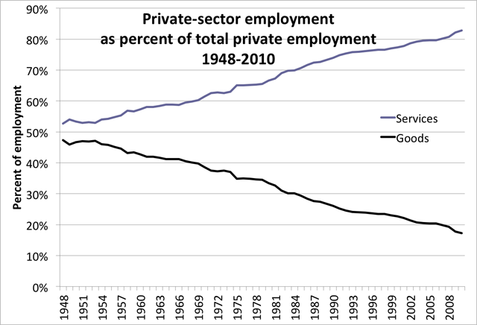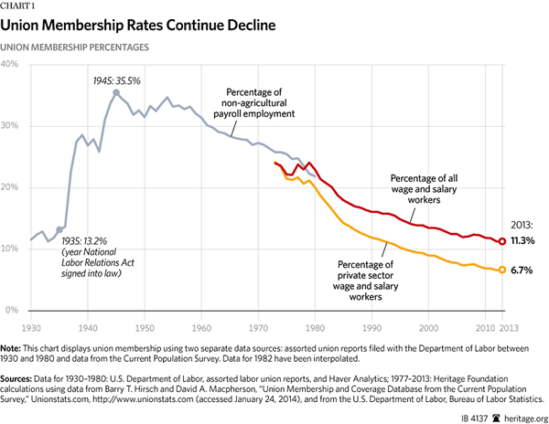
MC Questions –
Each of the questions below is related to the charts presented above.
- Which of the following statements accurately describes the comparison between the two charts above?
  - “As the US economy employed more people in the service industry, union membership declined.”
  - “As the US labor force changed from manufacturing to service industry, wages decreased.”
  - “As service industry labor increased, the amount of goods produced in the United States decreased.”
  - “In 1950, roughly half of all American workers were members of a Union.”
- Which of the following events could have influenced union membership after 1945?
  - The beginning of the Cold War
  - The beginning of the Women’s Liberation movement.
  - The end of World War II.
  - The beginning of the Civil Rights movement.
- Based upon evidence from the charts above, which of the following would be the best argument for why union membership has declined?
  - Congressional acts written since 1930 have not been union friendly.
  - Service industry workers are harder to unionize than manufacturing sector workers.
  - Labor laws favor service industry workers.
  - Wages for service industry workers are higher than manufacturing sector workers.

9.2.II The U.S. population continued to undergo demographic shifts that had significant cultural and political consequences.
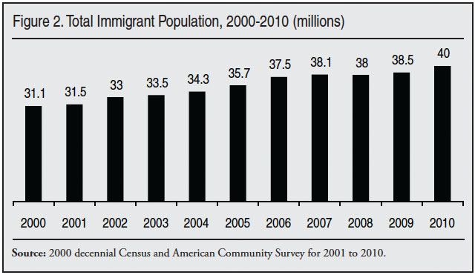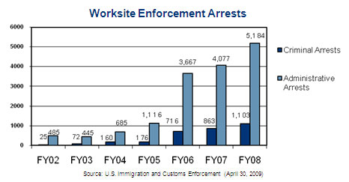
- Which of the following statements, as evidenced by the charts above, best describes the general correlation between the population of immigrants and its effect on the number of immigration related worksite arrests from 2002-2008?
  - As immigration rises, immigration related worksite arrests decline.
  - As immigration rises, immigration related worksite arrests rise.
  - As immigration declines, immigration related worksite arrests rise.
  - As immigration declines, immigration related worksite arrest decline.
- Which of the following pieces of legislation has had the most impact on immigration related worksite arrests?
  - Cuban Refugee Adjustment Act (1966)
  - Illegal Immigration Reform and Immigrant Responsibility Act (IIRIRA) of 1996
  - Immigration Reform and Control Act of 1986
  - Immigration and Nationality Act (1952)
- Which of the following would be the most accurate description of Congress during the time that immigration legislation was passed in 2006?
  - Republicans controlled both Congress and the White House
  - Democrats controlled both the House of Representatives and the Senate
  - Republicans controlled the House of Representatives, Democrats controlled the Senate.
  - Democrats controlled the House of Representatives, Republicans controlled the Senate.

