Document A. It seems to me that God, with infinite wisdom and skill, is training the Anglo-Saxon race for an hour sure to come in the world's future. Heretofore there has always been in the history of the world a comparatively unoccupied land westward, into which the crowded countries of the East have poured their surplus populations. But the widening waves of migration, which millenniums ago rolled east and west from the valley of the Euphrates, meet to-day on our Pacific coast. There are no more new worlds. The unoccupied arable lands of the earth are limited, and will soon be taken. The time is coming when the pressure of population on the means of subsistence will be felt here as it is now felt in Europe and Asia. Then will the world enter upon a new stage of its history-the final competition of races, for which the Anglo-Saxon is being schooled. Long before the thousand millions are here, the mighty centrifugal tendency, inherent in this stock and strengthened in the United States, will assert itself. Then this race of unequaled energy, with all the majesty of numbers and the might of wealth behind it-the representative, let us hope, of the largest liberty, the purest Christianity, the highest civilization-having developed peculiarly aggressive traits calculated to impress its institutions upon mankind, will spread itself over the earth. If I read not amiss, this powerful race will move down upon Mexico, down upon Central and South America, out upon the islands of the sea, over upon Africa and beyond. And can anyone doubt that the result of this competition of races will be the "survival of the fittest?"
Excerpted from Josiah Strong, Our Country (1885).

Document B. I, Liliuokalani of Hawaii…do hereby protest against the ratification of a certain treaty…purporting to cede those Islands to the territory and dominion of the United States. I declare such a treaty to be an act of wrong toward the native and part-native people of Hawaii, an invasion of the rights of the ruling chiefs, in violation of international rights both toward my people and toward friendly nations with whom they have made treaties, the perpetuation of the fraud whereby the constitutional government was overthrown, and, finally, an act of gross injustice to me…
Because that protest and my communications to the United States Government immediately thereafter expressly declare that I yielded my authority to the forces of the United States in order to avoid bloodshed, and because I recognized the futility of a conflict with so formidable a power.
Because the President of the United States, the Secretary of State, and an envoy commissioned by them reported in official documents that my government was unlawfully coerced by the forces, diplomatic and naval, of the United States; that I was at the date of their investigations the constitutional ruler of my people…
Therefore I, Liliuokalani of Hawaii, do hereby call upon the President of that nation, to whom alone I yielded my property and my authority, to withdraw said treaty (ceding said Islands) from further consideration. I ask the honorable Senate of the United States to decline to ratify said treaty, and I implore the people of this great and good nation, from whom my ancestors learned the Christian religion, to sustain their representatives in such acts of justice and equity as may be in accord with the principles of their fathers, and to the Almighty Ruler of the universe, to him who judgeth righteously, I commit my cause.
Liliuokalani, Abdication speech, June 17, 1897

Document C
We Filipinos have all along believed that if the American nation at large knew exactly, as we do, what is daily happening in the Philippine Islands, they would rise en masse, and demand that this barbaric war should stop. There are other methods of securing sovereignty the true and lasting sovereignty that has its foundation in the hearts of the people…
And, did America recognize this fact, she would cease to be the laughing stock of other civilized nations, as she became when she abandoned her traditions and set up a double standard of government--government by consent in America, government by force in the Philippine Islands? Let us look at the situation exactly as it is, as we know it to be, and let the American people no longer deceive themselves or be deceived by others. . .
You have been deceived all along the line. You have been greatly deceived in the personality of my countrymen. You went to the Philippines under the impression that their inhabitants were ignorant savages, whom Spain had kept in subjection at the bayonet’s point… We have been represented by your popular press as if we were Africans or Mohawk Indians. We smile, and deplore the want of ethnological knowledge on the part of our literary friends. We are none of these. We are simply Filipinos. You know us now in part: you will know us better, I hope, by and by.

Emilio Aguinaldo
NORTH AMERICAN REVIEW
September 1899 – Excerpts
Document D
It is a noble land that God has given us; a land that can feed and clothe the world; a land whose coastlines would enclose half the countries of Europe; a land set like a sentinel between the two imperial oceans of the globe, a greater England with a nobler destiny.
It is a mighty people that He has planted on this soil; a people sprung from the most masterful blood of history; a people perpetually revitalized by the virile, man-producing, working-folk of all the earth; a people imperial by virtue of their power, by right of their institutions, by authority of their Heaven-directed purposes-the propagandists and not the misers of liberty.
It is a glorious history our God has bestowed upon His chosen people; a history heroic with faith in our mission and our future; a history of statesmen who flung the boundaries of the Republic out into unexplored lands and savage wilderness; a history of soldiers who carried the flag across blazing deserts and through the ranks of hostile mountains, even to the gates of sunset; a history of a multiplying people who overran a continent in half a century; a history of prophets who saw the consequences of evils inherited from the past and of martyrs who died to save us from them; a history divinely logical, in the process of whose tremendous reasoning we find ourselves today.

Albert J. Beveridge, “March of the Flag”, Address to an Indiana Republican Meeting, Indianapolis, Indiana, 16 September 1898

Document E
In the forcible annexation of the Philippines our Nation neither adds to its strength nor secures broader opportunities for the American people. Even if the principle of conquest were permissible under American public law, the conquest of territory so remote from our shores, inhabited by people who have no sympathy with our history or our customs, and who resent our attempt to overthrow their declaration of independence, would be a tax upon our military and naval strength the magnitude of which cannot now be determined.
Who can estimate in money and men the cost of subduing and keeping in subjection eight millions of people, six thousand miles away, scattered over twelve hundred islands and living under a tropical sun? . . .
If this question is to be settled upon the basis of dollars and cents, who will insure the Nation that the receipts will equal the expenditures? Who will guarantee that the income from the Philippines, be it great or small, will find its way back to the pockets of the people who, through taxation, will furnish the money? And even if the amount invested in ships, armament and in the equipment of soldiers is returned dollar for dollar, who will place a price upon the blood that will be shed? If war is to be waged for trade, how much trade ought to be demanded in exchange for a human life? And will the man who expects to secure the trade risk his own life or the life of someone else?

William Jennings Bryan, “Will it Pay?” New York Journal, 15 January 1899 Excerpts

Document F
IN speaking to you, men of the greatest city of the West, men of the State which gave to the country Lincoln and Grant, men who preëminently and distinctly embody all that is most American in the American character, I wish to preach, not the doctrine of ignoble ease, but the doctrine of the strenuous life, the life of toil and effort, of labor and strife; to preach that highest form of success which comes, not to the man who desires mere easy peace, but to the man who does not shrink from danger, from hardship, or from bitter toil, and who out of these wins the splendid ultimate triumph…
I preach to you, then, my countrymen, that our country calls not for the life of ease but for the life of strenuous endeavor. The twentieth century looms before us big with the fate of many nations. If we stand idly by, if we seek merely swollen, slothful ease and ignoble peace, if we shrink from the hard contests where men must win at hazard of their lives and at the risk of all they hold dear, then the bolder and stronger peoples will pass us by, and will win for themselves the domination of the world. Let us therefore boldly face the life of strife, resolute to do our duty well and manfully; resolute to uphold righteousness by deed and by word; resolute to be both honest and brave, to serve high ideals, yet to use practical methods. Above all, let us shrink from no strife, moral or physical, within or without the nation, provided we are certain that the strife is justified, for it is only through strife, through hard and dangerous endeavor, that we shall ultimately win the goal of true national greatness. Theodore Roosevelt (1858–1919). The Strenuous Life. 1900.
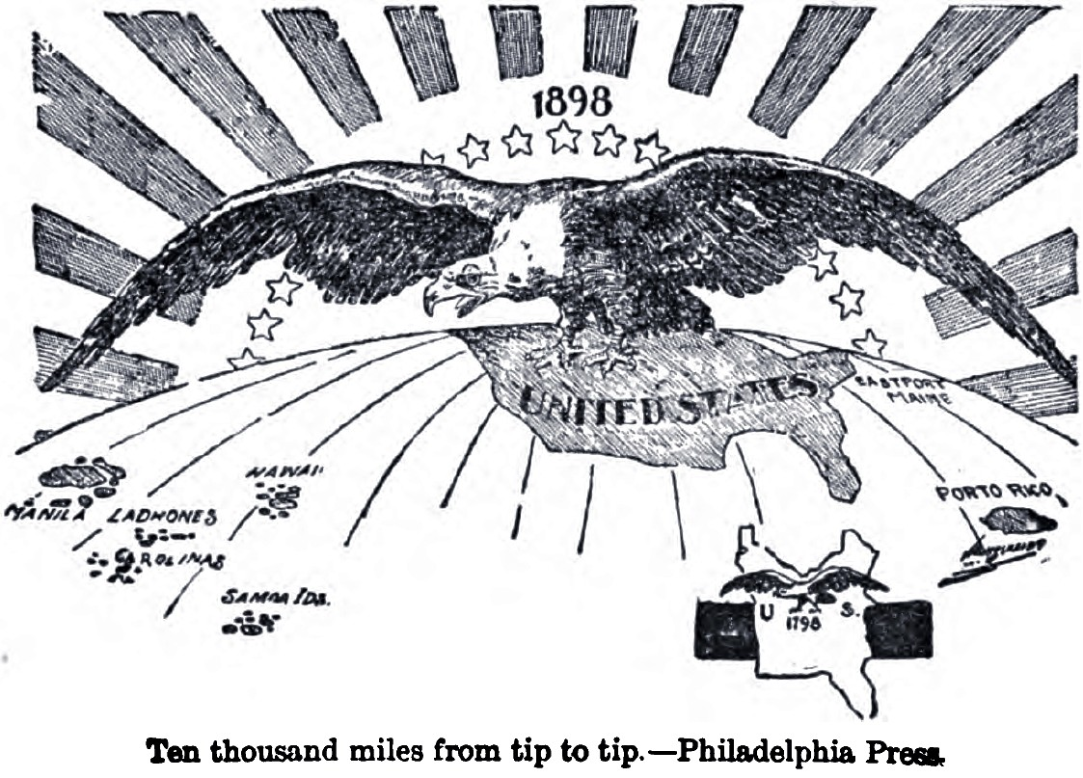
Document G

