Formative Quiz 9.3

Multiple Choice
Identify the choice that best completes the statement or answers the question.

Questions 1-3 refer to the speech below.

“...And now the Soviets themselves may, in a limited way, be coming to understand the importance of freedom. We hear much from Moscow about a new policy of reform and openness. Some political prisoners have been released. Certain foreign news broadcasts are no longer being jammed. Some economic enterprises have been permitted to operate with greater freedom from state control. Are these the beginnings of profound changes in the Soviet state? Or are they token gestures, intended to raise false hopes in the West, or to strengthen the Soviet system without changing it? We welcome change and openness; for we believe that freedom and security go together, that the advance of human liberty can only strengthen the cause of world peace.

There is one sign the Soviets can make that would be unmistakable, that would advance dramatically the cause of freedom and peace. General Secretary Gorbachev, if you seek peace, if you seek prosperity for the Soviet Union and Eastern Europe, if you seek liberalization: Come here to this gate! Mr. Gorbachev, open this gate! Mr. Gorbachev, tear down this wall!...” Ronald Reagan, Address from the Brandenburg Gate (June 12, 1987)

- Which of the following post World War II events would have created the need for President Reagan’s 1987 address from the Brandenburg Gate?
  - The division of Berlin by the Soviet Union in order to preserve a communist influence in Germany
  - The failure of the Berlin Airlift in preserving democratic ideals in parts of Germany
  - The strategic initiative of the Truman Doctrine to assist countries in economic need
  - The attempt by the United States to keep both Korea and Vietnam from becoming communist

- What would be the primary reason for President Reagan’s address from the Brandenburg Gate?
  - Reagan was responding to the perceived threat that communism posed to Yugoslavian capitalism and democratic rights for its citizens.
  - Reagan was defending his stance that he knew nothing of the sale of weapons to Iran and the subsequent funding of anti-communist Sandinistas in Nicaragua.
  - Reagan was hopeful that Soviet reforms and prior diplomatic meetings with Mikhail Gorbachev would lead to a nuclear arms reduction for both countries.
  - Reagan doubted Soviet claims of reform, given the existence of the Berlin Wall and wanted to affirm U.S. commitment to freedom and democracy in Eastern Europe.

- What would be a possible result of President Reagan’s address from the Brandenburg Gate?
  - The United States would continue Reagan’s call for a Strategic Defense Initiative.
  - The Cold War ended with the collapse of the Soviet Union and communist states within Eastern Europe.
  - The United States entered into a Operation Desert Storm against Iraq.
  - The Soviet Union invaded Afghanistan to preserve a communist influence in the Middle East.

Multiple Choice
Identify the choice that best completes the statement or answers the question.

Questions 4-6 refer to the image below.

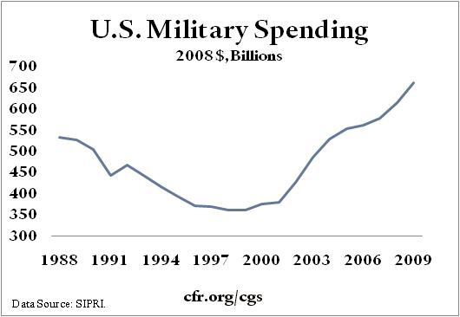

4. What significant event occurred in the early 21st Century that led to an increase in military spending as shown in the chart?
- Increased aggression on the part of North Korea to intimidate and influence neighboring countries.
- Attacks on the World Trade Center and the Pentagon by radical groups hostile to the United States.
- The election of a conservative administration dedicated to an increased military expansion.
- The increased military spending of Russia under the leadership of Vladimir Putin.

5. During what other time period were there similar increases in military spending to support US foreign policy efforts?
- High unemployment during the Great Depression and the need to support the New Deal efforts of the Roosevelt administration.
- Humanitarian efforts in Ethiopia and Somalia following significant droughts and famine.
- Increased intervention in American affairs by Cuba preceding the Spanish American War.
- The growing threat to our European allies in the late 1930’s and early 1940’s.

6. The short-lived spending increase in the early 1990’s occurred due to what primary factor?
- Conflicts in the Middle East that compelled the United States to protect its interest in fossil fuels.
- The invasion of the Kashmir region of India by Pakistan.
- FEMA’s response to the devastation of Hurricane Katrina along the Gulf coast.
- Efforts to gain the release of US State Department workers held hostage by the Iranian government.

