Formative Quiz 1.1

Multiple Choice
Identify the choice that best completes the statement or answers the question.

Questions 1-3 refer to the image below.

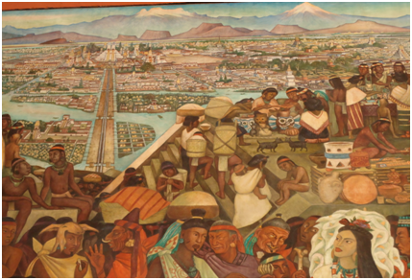
The Great Tenochtitlan by Diego Rivera in the Palacio Nacional

____ 1. The size and sophistication of Native American civilizations in Mexico and South America can be attributed to
a. | Spanish influences.
b. | their way of life based on hunting and gathering.
c. | the development of agriculture.
d. | influences brought by early settlers from Siberia.

____ 2. Native American (Indian) civilization was least highly developed in
a. | North America.
b. | Mexico.
c. | Central America.
d. | Peru.

____ 3. Which of the following developments resulted in greater social diversification among societies in North America prior to European contact?
a. | the development of highly sophisticated fishing and hunting techniques.
b. | the introduction of horses during the Columbian Exchange.
c. | the development of a calendar and sophisticated weaponry.
d. | The spread of maize cultivation into the American Southwest and beyond.

Questions 4-5 refer to the image below
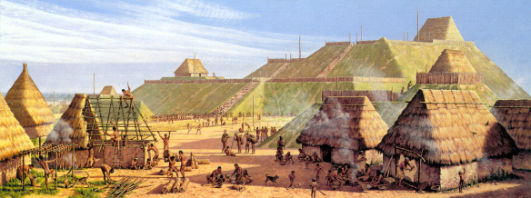
Cahokia Mounds, upper Mississippi Valley, mid-15th century.

____ 4. The development of "three sister" farming on the southeast Atlantic seaboard
a. | led to the dominance of the potato.
b. | ultimately failed to produce adequate amounts of food.
c. | was attributed to three young women of the Cherokee peoples.
d. | produced a rich diet that led to high population densities.

____ 5. Before the arrival of Europeans, Great Basin and Western Plains Indians
a. | developed larger permanent communities than those found in Mexico.
b. | responded to a lack of resources by developing mobile lifestyles.
c. | were engaged in constant warfare due to the lack of natural resources.
d. | created strong trade networks among North American tribes.
Question 6 refers to the excerpts below.
"To oppose those hordes of northern tribes, singly and alone, would prove certain destruction. We can make no progress in that way. We unite ourselves into one common band of brothers. We must have but one voice. Many voices makes confusion. We must have one fire, one pipe and one war club. This will give us strength. If our warriors are united they can defeat the enemy and drive them from our land; If we do this, we are safe . . . . And you of the different nations of the south, and you of the west, may place yourselves under our protection, and we will protect you. We earnestly desire the alliance and friendship of you all . . . ."
-Chief Elias Johnson, Legends, Traditions, and Laws of the Iroquois, or Six Nations, and History of the Tuscarora Indians, 1881

_____6. According to Johnson, which of the following was the primary reason for the tribes to unite?
- to increase economic trade through inter-tribal conflict.
- to promote warfare among tribes due to cultural misunderstandings.
- to gain additional land for the purpose of hunting and gathering.
- to encourage the Tuscarora leaders to form defensive alliances.

