Key Concept 8.2

Multiple Choice
Identify the choice that best completes the statement or answers the question.

Questions 1-2 refer to the image below.
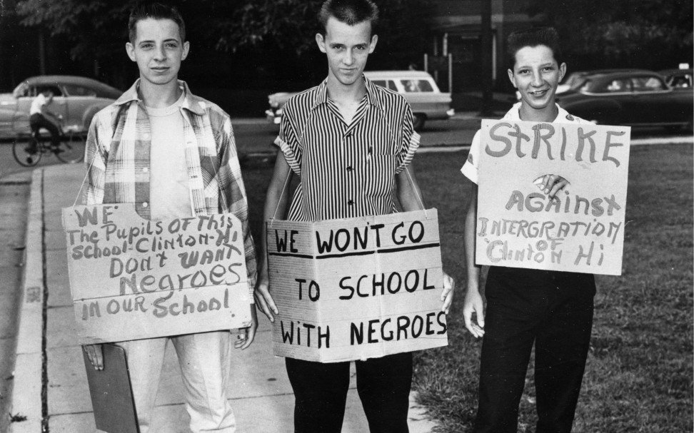

- Which of the Supreme Court decisions demonstrated the strongest connection with the idea expressed in this photo?
  - Plessy v. Ferguson
  - California v. Bakke

Dred Scott v. Sandford

Brown v. Board of Education of Topeka

- The movement that resulted from the situation in the photo is most similar to which of the following movements connected to the Supreme Court case Roe v Wade?
  - Gay/Lesbian Rights
  - Latino Rights
  - Women’s Rights
  - Native American Rights

Questions 3-4 refer to the image below.
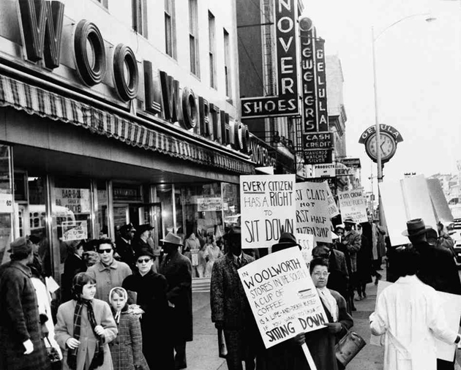

3. Which labor union/civil disobedience strategy are the people depicted in the photo implementing?
- Scabs
- Sit-ins
- Closed shop
- Arbitration
4. What societal changes developed as an outcome of the event in the photo?
- Due to these protests, gay and lesbian citizens may now legally marry.
- After these protests and others, public integration became more prevalent.
- As a result of the protests, Native Americans were forced to live on Reservations.
- Factory workers were able to get a high wage, increasing their standard of living.

Questions 5-6 refer to the passage below.

“It is the policy of the United States to provide, within constitutional limitations, for fair housing throughout the United States.” - Fair Housing Act 1968

5. Which group was not protected under the Fair Housing Act, but could have used this protection during the mid twentieth century?
- A Japanese immigrant moving to New York City for the first time.
- A Mormon minister renting a home near his church.
- An African-American farmer who has moved to Chicago to work in a factory.
- A lesbian college professor at Meredith College in Raleigh, NC.
6. Which of the following processes in society led to the passages of this legislation?
- Immigration increased at an alarming rate, making housing more scarce.
- As a result of the Vietnam war, large numbers of African-Americans were coming back from the war and could not find houses to buy or rent because of their skin color.
- The growth of the suburbs in areas like Levittown caused an over saturation of the housing market.
- Political bosses continued to give housing opportunities to people who voted for their candidate.

Questions 7-9 refer to the image below.
Figure 1.1
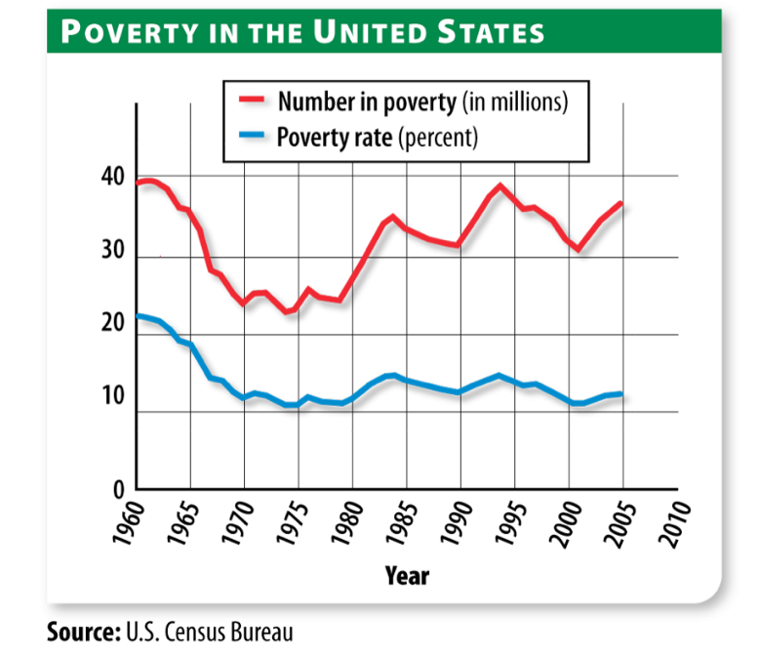
7. Between 1960 and 1980, the origins of the trend depicted in Figure 1.1 can most directly be traced back to which of the following?
a. Unemployment rates increased due to the economic demand created by the Cold
War.
b. Congress enacted legislation that guaranteed more equitable voting rotes for racial
minorities.
c. The federal government increased spending on social welfare programs.
d. Confidence in the American economy waned as the Vietnam War lingered on.

8. Between 1960 and 1980, which of the following groups were most critical of the federal government’s attempt to address the economic trend depicted in Figure 1.1?
a. Middle class
b. African Americans
c. Women
d. Latinos

9. Which of the following presidents differed the most from Lyndon B. Johnson in their approach to the problem of poverty?
a. Ronald Reagan
b. Franklin D. Roosevelt
c. Woodrow Wilson
d. John F. Kennedy

Answer Key
- d
- c
- b
- b
- d
- b
- c
- a
- a

