Key Concept 7.3
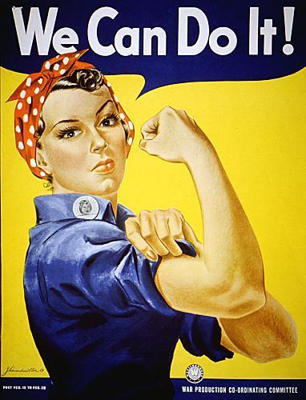
- Which best states the attitude of the American people during WWII that the illustration above helped to demonstrate?
- Majority of the people believed that the war was unfair.
- Majority of the people believed that women were not helping enough
- Few people opposed the war, increasing war productivity
- Few people had jobs, especially among women.

2. Which aspect of America’s involvement in World War II is best illustrated by this painting?
a. Technological and scientific contributions
b. The popular commitment to advancing democratic ideals
c. Questions about American values
d. The mass mobilization of American society to the war effort

3. The illustration above best supports which of the following claim?
a. The Great Depression had been brought to an end by full employment.
b. The United States continued to apply an isolationist foreign policy.
c. African Americans were denied opportunities to participate in the wartime labor force.
d. America would play a dominant role in the postwar peace settlements due to its commitment to democratic ideals.

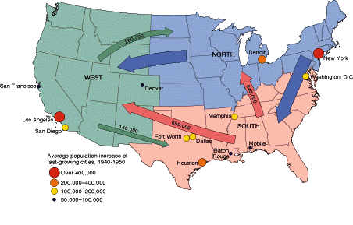
Source: Thomas A. Bailey, David M. Kennedy, and Lizabeth Cohen.
The American Pageant, 11th ed. (Boston: Houghton Mifflin Co., 1998), 854.
4. Which of the following would best support the reasons for the internal migration depicted in the source above during mid 20th century?
- Minority groups like African Americans left the south because of the large demand of jobs.
- Minority groups like Mexican Americans migrated to the north because of the demand of agricultural jobs.
- African American left the south because most of the jobs were taken by women in the south region.
- Japanese were antagonized during WWII therefore migrated to other parts of the United States.

5. Which is a result of the internal migration of the mid 20th century?
- There was a wide tolerance of minorities groups across the United States.
- It was very difficult for women to find jobs.
- It led racial riots in New York and Detroit
- Many Mexicans were able to enter the country legally

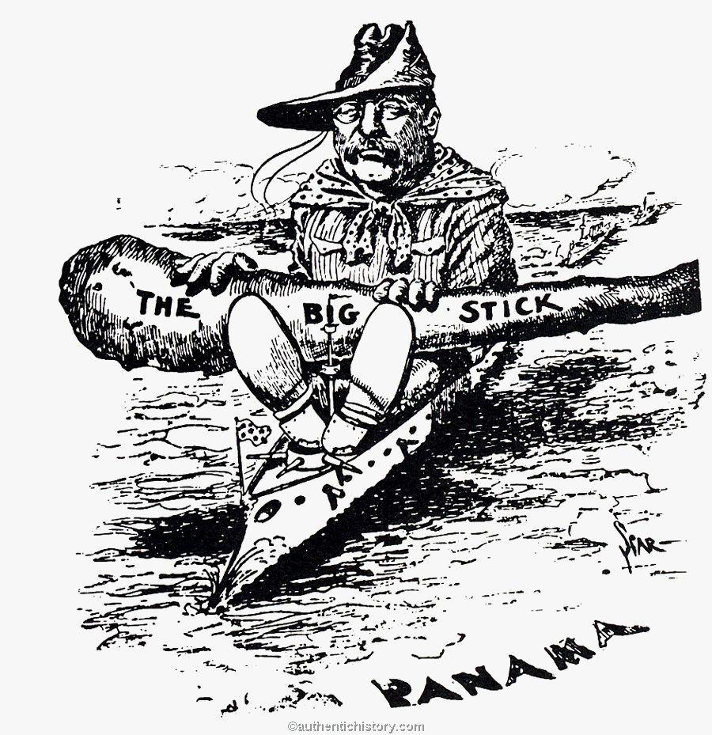

6. This political cartoon most clearly depicts which of the following historical developments in the late 19th and early twentieth centuries?

a. Imperialism
b. Industrialization
c. isolationism
d. immigration

7. The cartoon most directly reflects a growing belief that:

- America should pursue military involvement in the Western hemisphere
- Isolationism would improve the American economy
- America should spread democracy to other countries
- the American government should pursue nation building

8. The cartoon above represents a continuation of what earlier 19th century movement

a. Manifest Destiny
b. Populism
c. Social Gospel
d. Nativism

