Formative Quiz 5.2
Questions 1-3 refer to the excerpt below.
The question is simply this: can a negro whose ancestors were imported into this country and sold as slaves become a member of the political community formed and brought into existence by the Constitution of the United States, and as such become entitled to all the rights, and privileges, and immunities, guaranteed by that instrument to the citizen, one of which rights is the privilege of suing in a court of the United States in the cases specified in the Constitution?
In the opinion of the court, the legislation and histories of the times, and the language used in the Declaration of Independence, show that neither the class of persons who had been imported as slaves nor their descendants, whether they had become free or not, were then acknowledged as a part of the people, nor intended to be included in the general words used in that memorable instrument.
Source: Dred Scott v. Sanford; Chief Justice Taney majority opinion, March 1857
- Which of the following decisions or government actions further supported Taney’s view of the status of African Americans?
  - Brown v. Board of Education, which settled the issue of separate but equal
  - Plessy v. Ferguson, which endorsed racial segregation laws
  - Regents of the University of California v. Bakke, which limited affirmative action programs
  - The Reconstruction amendments, which outlined the rights of United States citizens

- Which of the following resulted from the Supreme Court’s decision in Dred Scott v. Sanford?
  - An increase in sectional tensions regarding the legal status of slaves
  - Continued debate over ratification of the Kansas-Nebraska Act
  - The advent of the creation of the Free-Soil Party
  - The reimplementation of the Missouri Compromise

- The Dred Scott decision is most similar to the beliefs expressed by
  - Northern industrialists who sought a cheap labor force
  - Free-Soilers who advocated economic opportunities for white males
  - Southern aristocracy who wanted to maintain the social status quo
  - Republicans who were willing to accept slavery yet not its extension

Questions 4-6 refer to the image below.
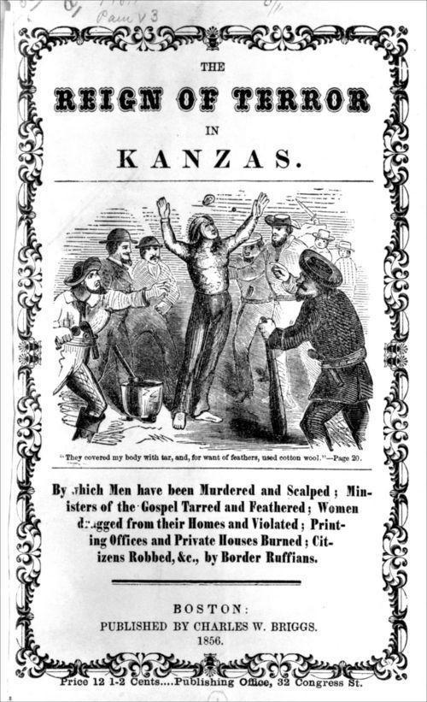
- One reason for southern dissatisfaction concerning the Missouri Compromise was:
  - Belief that future states established in new territory would upset the balance of power in Congress
  - The acquisition of Louisiana was unconstitutional
  - Navigation of the Mississippi would be infringed
  - Incorporation of new territories extended republican institutions and intensified conflicts with Native Americans

- Violence in Kansas in the 1850’s can be described as an ideological conflict between
  - The free labor manufacturing economy and a slave based agricultural economy.
  - States’ rights and debates over the status of newly created territories.
  - Inconsistencies in the second party system.
  - The issues set forth in the Emancipation Proclamation.

- The 13th Amendment accomplished all of the following EXCEPT
  - Private ownership of land for the majority of former slaves.
  - The end of legalized slavery in the U.S.
  - Dramatic social and political change.
  - A road to citizenship for former slaves and equal protection.

Questions 7-9 Refer to the two excerpts below.

“Section 6: when a person held to labor in any State, has escaped into another State, the person to whom such labor may be due ... may pursue and reclaim such fugitive person, either by warrant, ... or by seizing and arresting such fugitive; and ... to use such reasonable force and restraint as may be necessary
Section 7: any person who shall willingly hinder from arresting such a fugitive, or shall rescue, or attempt to rescue, such fugitive from labor, from the custody of such claimant ...; or shall aid, abet, or assist such person ... to escape from such claimant ...; or shall harbor or conceal such fugitive, shall, be subject to a fine not exceeding one thousand dollars, and imprisonment not exceeding six months ...; and shall pay the sum of one thousand dollars for each fugitive so lost”
Fugitive Slave Act, 1850

“Far in the West rolls the thunder –
The tumult of battle is raging
Where bleeding Kansas is waging
War against Slavery”
-The New York Tribune, Charles C. Weyman, 1856

- Weyman wrote this poem in response to
  - Legislation that provided for popular sovereignty in the territory of Kansas
  - Court rulings that allowed for the gradual emancipation of all slaves in the western territories
  - The support of the newly elected Congressional leaders who promoted abolition
  - Increased demand for slaves to work in the growth of factories developing in newly acquired territories like Kansas

- The actions described in both excerpts would provide outrage from which of the following groups:
  - Northern abolitionists
  - Western farmers
  - Conservative preachers
  - Indian tribes

- Which future development in regards to slavery would invalidate both provisions of the Fugitive Slave Act and the Kansas Nebraska Act?
  - The requirement for all states to ratify the 14th amendment
  - Most Southerners gave up their desire to recover escaped slaves during the 1850s
  - Northern abolitionists weakened in their support of emancipation of slaves
  - The outcome of a Southern Civil War victory

