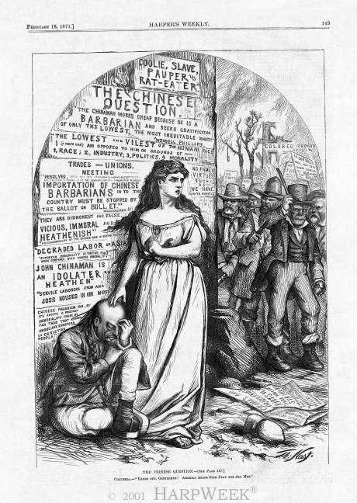
- The author of this cartoon would most likely support which of the following?
  - Popular violence reinforcing white dominance
  - Constitutional amendments extending citizenship rights to African Americans
  - The religious and cultural assimilation of Chinese immigrants
  - Nativist sentiments embracing “whites only” immigration policies

- The opposition to Chinese migration depicted in this cartoon first became widespread in
  - the industrial Midwest.
  - the agricultural South.
  - East-coast metropolises.
  - Western commercial hubs.

- All of the following were significant factors motivating the mob depicted in this cartoon EXCEPT
  - adherence to free trade practices.
  - belief in white racial superiority.
  - anxiety over wage fluctuations.
  - support for labor organization movements.

“The association of poverty with progress is the great enigma of our times. So long as all the increased wealth which modern progress brings goes but to build up great fortunes, to increase luxury and make sharper the contrast between the house of have and the house of want, progress is not real and cannot be permanent.”
-- Henry George,

- Which of the following groups of people would agree with George’s claim:
- Industrial workers
- Those at the top of the economic structure
- Political Machines
- Senators who protect big business

- George’s views best reflect which of the following:
- Rising grassroots challenges to the dominant economic system
- Americanization
- Social Darwinism
- Westward Migration

- People who agreed with George’s argument would have most likely agreed with which of the following solutions:
- Abolishment of the sharecropping system
- Court cases protecting monopolies
- Weaker labor unions
- Reduced government involvement in the economy

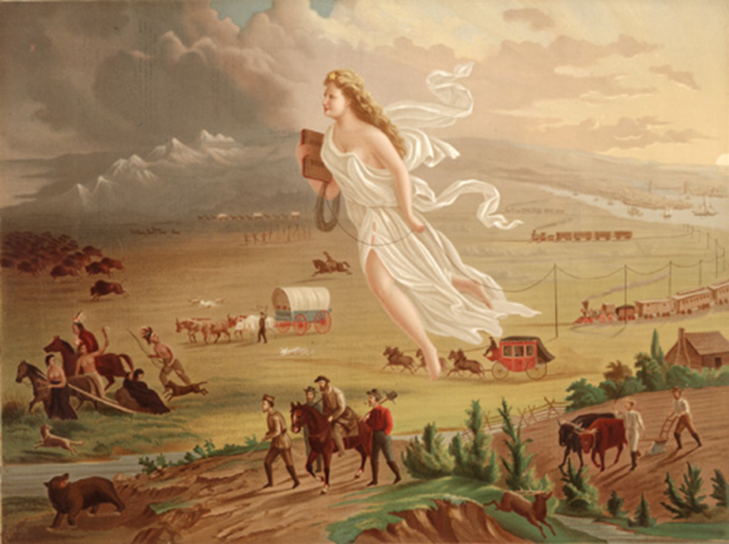

- Which major concept did the artist intend to glorify in the image above?
A. Social Darwinism
B. Manifest Destiny
C. Native Culture
D. The Gospel of Wealth

- Which of the following groups would most likely support the perspective of the image?
- Native Americans, such as Sitting Bull
- Preservationists, such as John Muir
- Railroad entrepreneurs, such as Cornelius Vanderbilt
- Antebellum reformers, such as Dorothea Dix

- The controversy highlighted in the image above most directly led to
- Competition in the West among white settlers, Indians, and Mexican Americans
- Increasing rates of unemployment in the industrialized Eastern states
- The passage of the 19th amendment for female suffrage
- The removal of peaceful western, native tribes to eastern reservations

