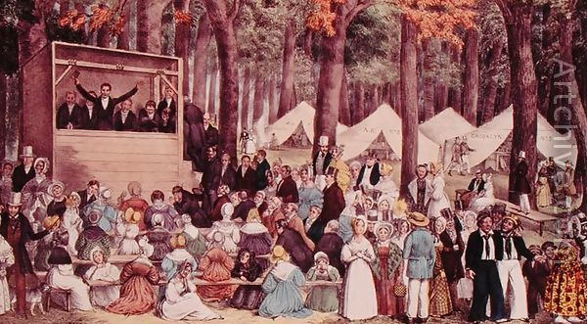

Methodist Campaign Meeting, 1837
The Granger Collection, NYC

- Meetings like those shown in the image contributed most directly to which of the following?
  - Religious revivals fostering the rise of social elitism in Southern states
  - A decline in the efforts to free enslaved African Americans in both the North and South
  - The rise of xenophobia and nativist sentiments within the United States
  - The promotion of religious and social reforms, including abolition and women’s rights

- The types of meetings depicted in the image most directly resulted in
  - Revivals open to all races leading to occasional racial unrest in the South
  - Political and economic loyalties overshadowing national concerns
  - Anti-slavery sentiments among Southern women
  - Revivals leading to an increase in educational opportunities for African Americans

- The painting most directly reflects the
  - Sentiments of Old World Calvinists in regards to predestination
  - Promotion of the temperance movement in rural America
  - Emergence of evangelical Protestantism as the dominant form of Christianity in the United States
  - Relationship between Methodist and Catholic theology

When, in the course of human events, it becomes necessary for one portion of the family of man to assume among the people of the earth a position different from that which they have hitherto occupied... a decent respect to the opinions of mankind requires that they should declare the causes that impel them to such a course.
We hold these truths to be self‐evident: that all men and women are created equal; that they are endowed by their Creator with certain inalienable rights; that among these are life, liberty, and the pursuit of happiness...
The history of mankind is a history of repeated injuries and usurpations on the part of man toward woman, having in direct object the establishment of an absolute tyranny over her.
Excerpt from the Seneca Falls “Declaration of Sentiments” 1848
- The above excerpt represents a break from which of the following late 18th century cultural movement?
  - Increased belief in Transcendentalism
  - A general acceptance of the Cult of Domesticity
  - Embracing Republican Motherhood
  - The expansion of the Temperance movement

- Which 20th Century reformer demonstrates the strongest continuity with the ideas expressed in the passage?
  - Phyllis Schlafly
  - Betty Friedan
  - Eleanor Roosevelt
  - Ida Tarbell

- Which of the following represents a long-term impact of the Seneca Falls Convention?
  - The adoption of Affirmative Action Policies
  - Johnson’s Great Society Programs
  - Implementation of the New Deal
  - The passage of the 19th Amendment

“We might feel a pride in the reflection, that our young country… was the first to adopt with any efficacy, the penitentiary system of prison discipline, and the first to attempt to prevent the commission of crimes, by seeking out the youthful and unprotected, who were in the way of temptation, and by religious and moral instruction, by imparting to them useful knowledge, and by giving them industrious and orderly habits, rescuing them from vice, and rendering them valuable members of society… To confine these youthful criminals… where no, or scarcely any, distinction can be made between the young and the old, or between the more or less vicious, where little can be learned but the ways of the wicked, and from whence they must be sent to encounter new wants, new temptation, and to commit new crimes, is to pursue a course, as little reconcilable with justice as humanity: Yet, till the House of Refuge was established there was no alternative.”
Society for the Reformation of Juvenile Delinquents in the City of New York, Fourth Annual Report- 1829
- The above account best reflects what growing reform sentiment during the period 1820 to 1848?
  - Belief in the perfectibility of man
  - Commitment to egalitarianism
  - Acceptance of transcendental philosophy
  - Commitment to the philosophy of predestination

- Reform movements concerned with all of the following emerged in the same time period EXCEPT:
  - Women’s rights
  - Environmental preservation
  - Temperance
  - Public education

- During the period 1800-1848, reform movements were most successful in achieving their goals in which of the following?
  - The granting of women’s suffrage through the Nineteenth Amendment
  - Prohibition established through the Eighteenth Amendment
  - State laws focusing on improved public education
  - Establishment of federal standard for minimum wage and maximum hours

