Formative Quiz 1.3

Questions 1-3 refer to the excerpt below.

“’The discovery of America,’ the Scottish writer Adam Smith announced…was one of the “two greatest and most important events recorded in the history of mankind.”…It is not surprising that looking back nearly three centuries after the initial voyage of Christopher Columbus in 1492, Smith focused primarily on the economic results of the conquest and colonization of North and South America. The influx of goods from the New World, he insisted, greatly increased the “enjoyments” of the people of Europe and the market for European goods. Nonetheless, Smith did not fail to note the price paid by the indigenous population of the New World… ‘Benefits’ for some, Smith observed, went hand in hand with the ‘dreadful misfortunes’ for others…”
- Eric Foner, Voices of Freedom: A Documentary History Vol. I, 2014

1. Which of the following evidence would best support Foner’s selection of these particular Adam Smith quotes in the excerpt?
a. Census data comparing the indigenous population of the Americas from the years 1491 and 1776.
b. Columbus’ diary
c. A sampling of treaties made between European nation-states and Native American tribes in the 18th century.
d. Economic data detailing European imports and exports from the years 1491 and 1776

2. “The influx of goods from the New World…” is a reference to what historical phenomenon?
a. The Columbian Exchange
b. The mercantilist system
c. The slave trade
d. The spread of Enlightenment ideals

3. What is the most likely reason that Foner would argue that it was “not surprising that…Smith focused primarily on the economic results…” of the colonization of the New World?
a. Smith was an advocate of laissez faire economics
b. Smith became very wealthy as a result of trade with North America
c. Smith was European, and all 18th-century Europeans cared only for acquiring wealth
d. Smith is known as the founder of modern economics and author of The Wealth of Nations

Questions 4-7 refer to the image below.
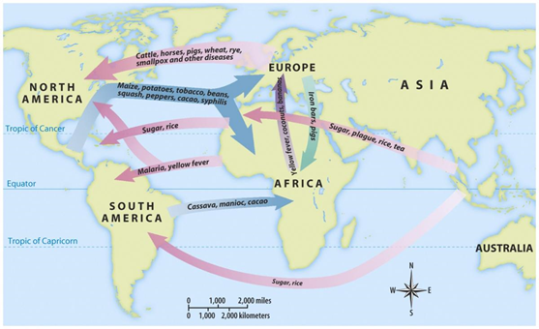
4. Which development was most responsible for the interaction depicted in the image above?
a. the religious and social upheavals caused by the Crusades
b. the desire to sponsor trans-Atlantic voyages by European monarchs
c. technological advancements that improved navigation and sailing capabilities
d. the growth of agriculture in the Americas during the 15th century

5. What was the most significant effect of the interaction depicted in the image above?
a. the rapid decimation of Native American populations
b. the creation of a new Mestizo race in the Americas
c. the exchange of diseases between North America and Europe
d. the exchange of sugar and rice from Africa to the Caribbean

6. Of the items exchanged, the one that had the greatest impact on Native American lifestyles on the Great Plains of North America was
a. the horse
b. corn
c. guns
d. the compass

7. The event depicted in the image best corresponds to which time period?
a. 1491-1607
b. 1800-1848
c. 1890-1945
d. 1980-Present

