Formative Quiz 1.2

Questions 1-3 refer to the excerpt below.

"Concerning the treatment of Native American workers:
When they were allowed to go home, they often found it deserted and had no other recourse than to go out into the woods to find food and to die. When they fell ill, which was very frequently because they are a delicate people unaccustomed to such work, the Spaniards did not believe them and pitilessly called them lazy dogs, and kicked and beat them; and when illness was apparent they sent them home as useless, giving them some cassava for the twenty-to eighty­ league journey. They would go then, falling into the first stream and dying there in desperation; others would hold on longer, but very few ever made it home. I sometimes came upon dead bodies on my way, and upon others who were gasping and moaning in their death agony, repeating 'Hungry, hungry."'
-Bartolome de Las Casas, priest and social reformer,
In Defense of the Indian, c. 1550

- Which of the following best explains the underlying cause of the Spanish actions described by Las Casas?
  - racism and the desire for wealth
  - attempts at religious conversion
  - desire to acquire more land
  - innate fear of native power

- The primary audience that Las Casas hoped to influence by his writing was
  - the monarchs of Spain
  - the Roman Catholic Church
  - the conquistadores
  - the Native Americans

- Which of the following factors that affected Native Americans is directly implied but not stated in this excerpt?
  - many Spaniards were sympathetic to the Native Americans
  - the Catholic Church was trying to help the Native Americans
  - European diseases were killing millions of Native Americans
  - the Spanish faced strong resistance from Native Americans

4. The most significant initial impact on the Native American population from interaction
with Europeans came from:
a. the exchange of technology such as guns, metals, and horses.
b. old world diseases from which they had little immunity.
c. domesticated livestock, which created much greater food variety.
d. seeds and plants, which transformed the landscape of North America.

Questions 5-7 refer to the painting below.

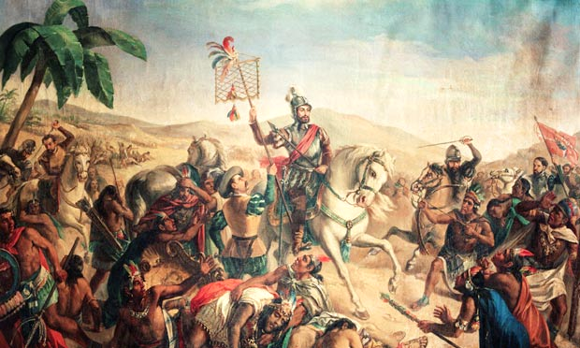
Source: Aztecs under attack: Hernan Cortez. Retrieved from http://www.theguardian.com

- This painting was most likely intended to
a. glorify the impact of the Columbian Exchange
b. increase support for the Encomienda system
c. gain sympathy for the American Indians being slaughtered by the Spanish explorers
d. demonstrate the traditional lifestyles of the American Indians upon European arrival

    - The event shown in the painting came about most directly as a result of
a. American Indian acceptance of European cultural practices
b. the developing European belief that white superiority was justification for conquest
c. European rejection of African slavery
d. unsuccessful efforts by the European explorers to gain economic and political power

    - Advocates for the events shown in the image would most likely have agreed with which of the following in later time periods?
a. political and cultural autonomy of the native peoples
b. sovereignty for all American Indian tribes
c. increased uprisings by the American Indians
d. federal effort to remove and control the American Indians

