Formative Assessment 4.3

Questions 1 and 2 refer to the excerpt below

“I cannot but remark, sir, to what lengths arguments might be carried, predicated upon the supposition of the existence of the power, on the part of congress, to impose conditions and restrictions.
If you have the authority to impose the one now sought to be imposed, may you not impose any other? If you have the right to inhibit the introduction of slaves into the new state, you have a right to inhibit the introduction of any other species of property. And you may go a step further, and prescribe the manner in which the soil shall be cultivated. In fine, there is no restriction or condition whatever, which may not, with equal propriety, be imposed.”
-Senator Freeman Walker (Georgia) 1819

1. Which of the following groups would be most likely to support the perspective of Senator Freeman Walker?

- the emerging Republican Party
- Southern Democrats
- the growing Northern anti-slavery movement
- Northern merchants

2. Senator Walker’s speech and The Congressional Debate centered around which piece of legislation?
- the Northwest Ordinance
- the Missouri Compromise
- the Monroe Doctrine
- the Indian Removal Act

Question 3 refers to the excerpt below

“Section 6: when a person held to labor in any State, has escaped into another State, the person to whom such labor may be due ... may pursue and reclaim such fugitive person, either by warrant, ... or by seizing and arresting such fugitive; and... to use such reasonable force and restraint as may be necessary

Section 7: any person who shall willingly hinder from arresting such a fugitive, or shall rescue, or attempt to rescue, such fugitive from labor, from the custody of such claimant ...; or shall aid, abet, or assist such person ... to escape from such claimant ...; or shall harbor or conceal such fugitive, shall, be subject to a fine not exceeding one thousand dollars, and imprisonment not exceeding six months ...; and shall pay the sum of one thousand dollars for each fugitive so lost”
-Fugitive Slave Law Act 1850

“Far in the West rolls the thunder –
The tumult of battle is raging
Where bleeding Kansas is waging
War against Slavery”
-The New York Tribune, Charles C. Weyman, 1856

3. Weyman wrote this poem in response to

- Legislation that provided for popular sovereignty in the territory of Kansas
- Court rulings that allowed for the gradual emancipation of all slaves in the western territories
- The support of the newly elected Congressional leaders who promoted abolition
- Increased demand for slaves to work in the growth of factories developing in newly acquired territories like Kansas

Question 4 refers to the picture below
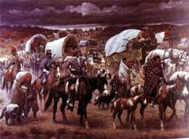

4. The painting above illustrates Andrew Jackson’s Native American policy that was expressed in the
- Indian Removal Act
- Monroe Doctrine
- Hartford Convention
- Webster-Ashburton Treaty

Question 5 refers to the excerpt below

“It is impossible that the allied powers should extend their political system to any portion of either continent without endangering our peace and happiness; nor can anyone believe that our southern brethren, if left to themselves, would adopt it of their own accord. It is equally impossible, therefore, that we should behold such interposition in any form with indifference. If we look to the comparative strength and resources of Spain and those new Governments, and their distance from each other, it must be obvious that she can never subdue them. It is still the true policy of the United States to leave the parties to themselves, in hope that other powers will pursue the same course. . . .”
- Monroe Doctrine, 1823

5. Which of the following political factors most directly contributed to this excerpt of the Monroe Doctrine?
- Economic instability of the United States to pay for additional wars
- Independence Movements in Latin America
- Outcome of the War of 1812
- British exploration of the Northwest territory

Question 6 refers to the picture below

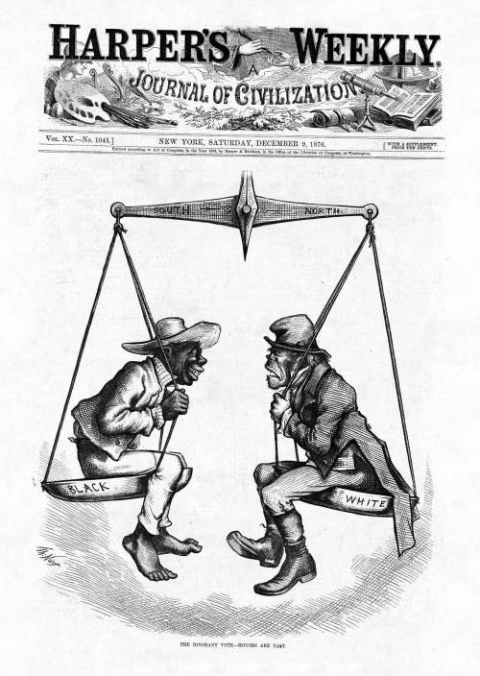

6. The sentiments expressed in this political cartoon most directly contributed to which of the following?
- rising xenophobia
- equality for people of both cultures
- voting rights issued to African Americans
- better treatment of Irish immigrants

Question 7 refers to the excerpt below

In a letter to William Short from April 13, 1820, Jefferson wrote that the "Missouri question aroused and filled me with alarm...I have been among the most sanguine in believing that our Union would be of long duration. I now doubt it much."

7. Which of the following future events best demonstrates that his concerns were well founded?
- Civil War
- The Dred Scott Decision
- Kansas-Nebraska Act
- John Brown’s Raid

Question 8, and 10 refers to the picture below
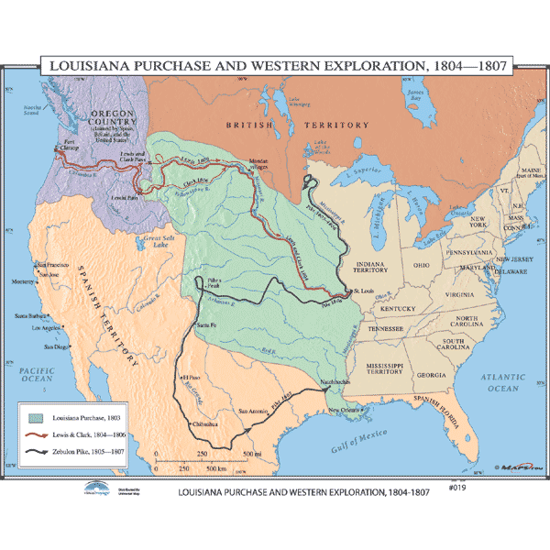
8. The Louisiana Purchase caused which of the following
- The drive to acquire, survey, and open up new lands and markets
- Trump national concerns such as slavery
- Widen the gap between the rich and poor
- The opening of new roads into western territories

9. Which of following ideas is best illustrated by the map above?
- Expansionism
- Republicanism
- Isolationism
- Imperialism

10. Which group of individuals will seek to benefit from the newly acquired territory?
- Federalists
- Democratic-Republicans
- Yeoman Farmers
- Bankers

