Questions 1 and 2 refer to the image below.

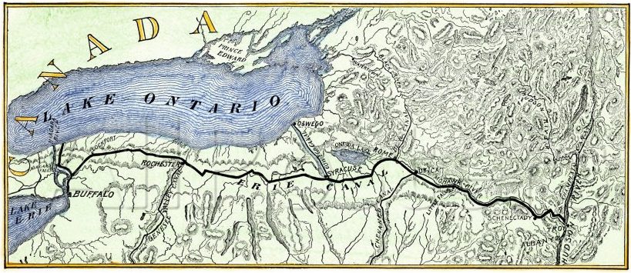
(Source: Map of the Erie Canal, 1820)

- The development in the map above would contribute most to which of the following?
A. Movement towards western portions of the United States territory
B. Calls for reduction of protective tariffs
C. Increased stimulus for immigration to the United States
D. Growth of agricultural business in the northern United States

- The construction of the Erie Canal would be most analogous to which of the following?
A.
B.
C.
D.

