United States History
Section II
Part A
(Suggested Writing Time 45 minutes)
Percent of Section II Score--45

Directions: The following question requires you to construct a coherent essay that integrates your interpretation of Documents A-J and your knowledge of the period referred to in the question. High scores will be earned only by essays that both cite key pieces of evidence from the documents and draw on outside knowledge of the period.

Question: To what extent did the Articles of Confederation provide a reasonable and workable transition from the system of British rule to the federal system established under the Constitution?

Document A

To all to whom these Presents shall come, we the undersigned Delegates of the States affixed to our Names send greeting.
Articles of Confederation and perpetual Union between the States of New Hampshire, Massachusetts bay, Rhode Island and Providence Plantations, Connecticut, New York, New Jersey, Pennsylvania, Delaware, Maryland, Virginia, North Carolina, South Carolina and Georgia…
Article II. Each state retains its sovereignty, freedom, and independence, and every power, jurisdiction, and right, which is not by this Confederation expressly delegated to the United States, in Congress assembled…
The Articles of Confederation, Preamble and Article II
Agreed to by Congress November 15, 1777; ratified and in force, March 1, 1781.

Document B
ART. 1. No person, demeaning himself in a peaceable and orderly manner, shall ever be molested on account of his mode of worship or religious sentiments, in the said territory.
ART. 2. The inhabitants of the said territory shall always be entitled to the benefits of the writ of habeas corpus, and of the trial by jury; of a proportionate representation of the people in the legislature; and of judicial proceedings according to the course of the common law…No man shall be deprived of his liberty or property, but by the judgment of his peers or the law of the land;
ART. 3. Religion, morality, and knowledge, being necessary to good government and the happiness of mankind, schools and the means of education shall forever be encouraged. The utmost good faith shall always be observed towards the Indians; their lands and property shall never be taken from them without their consent; and, in their property, rights, and liberty, they shall never be invaded or disturbed, unless in just and lawful wars authorized by Congress; but laws founded in justice and humanity, shall from time to time be made for preventing wrongs being done to them, and for preserving peace and friendship with them. . . .
ART. 5. There shall be formed in the said territory, not less than three nor more than five States. . . . And, whenever any of the said States shall have sixty thousand free inhabitants therein, such State shall be admitted, by its delegates, into the Congress of the United States, on an equal footing with the original States in all respects whatever, and shall be at liberty to form a permanent constitution and State government…
ART. 6. There shall be neither slavery nor involuntary servitude in the said territory…

The Northwest Ordinance (1787) (excerpted)

Document C

Article I. All men are born free and equal, and have certain natural, essential, and unalienable rights; among which may be reckoned the right of enjoying and defending their lives and liberties; that of acquiring, possessing, and protecting property; in fine, that of seeking and obtaining their safety and happiness.

A Declaration of the Rights of the Inhabitants
of the Commonwealth of Massachusetts.
Massachusetts Constitution, adopted June 15, 1780

Document D
The interest of the man must be connected with the constitutional rights of the place. It may be a reflection on human nature, that such devices should be necessary to control the abuses of government. But what is government itself, but the greatest of all reflections on human nature? If men were angels, no government would be necessary. If angels were to govern men, neither external nor internal controls on government would be necessary. In framing a government which is to be administered by men over men, the great difficulty lies in this: you must first enable the government to control the governed; and in the next place oblige it to control itself. A dependence on the people is, no doubt, the primary control on the government; but experience has taught mankind the necessity of auxiliary precautions.

The Federalist No. 51

The Structure of the Government Must Furnish the Proper Checks and Balances Between the Different Departments

Independent Journal
Wednesday, February 6, 1788
[James Madison]

Document E
…They who promote the idea of substituting a number of distinct confederacies in the room of the plan of the convention, seem clearly to foresee that the rejection of it would put the continuance of the Union in the utmost jeopardy. That certainly would be the case, and I sincerely wish that it may be as clearly foreseen by every good citizen, that whenever the dissolution of the Union arrives, America will have reason to exclaim, in the words of the poet: "FAREWELL! A LONG FAREWELL TO ALL MY GREATNESS."

The Federalist No. 2

Concerning Dangers from Foreign Force and Influence

Independent Journal
Wednesday, October 31, 1787
[John Jay]

Document F
…If a faction consists of less than a majority, relief is supplied by the republican principle, which enables the majority to defeat its sinister views by regular vote. It may clog the administration, it may convulse the society; but it will be unable to execute and mask its violence under the forms of the Constitution. When a majority is included in a faction, the form of popular government, on the other hand, enables it to sacrifice to its ruling passion or interest both the public good and the rights of other citizens. To secure the public good and private rights against the danger of such a faction, and at the same time to preserve the spirit and the form of popular government, is then the great object to which our inquiries are directed…

The Federalist No. 10

The Utility of the Union as a Safeguard Against Domestic Faction and Insurrection (continued)

Daily Advertiser
Thursday, November 22, 1787
[James Madison]

Document G

This Constitution is said to have beautiful features; but when I come to examine these features, sir, they appear to me horribly frightful. Among other deformities, it has an awful squinting; it squints towards monarchy; and does not this raise indignation in the breast of every true American?
Your President may easily become king. Your Senate is so imperfectly constructed that your dearest rights may be sacrificed by what may be a small minority; and a very small minority may continue forever unchangeably this government, {59} although horridly defective. Where are your checks in this government? Your strongholds will be in the hands of your enemies…
Patrick Henry — speeches in Virginia Ratifying Convention, Thursday, June 5, 1788

Document H
Document I
The Constitution is now before the judgment seat. It has, as was expected, its adversaries, and its supporters; which will preponderate is yet to be decided. The former, it is probable, will be most active because the Major part of them it is to be feared, will be governed by sinister and self important considerations on which no arguments will work conviction--the opposition from another class of them (if they are men of reflection, information and candor) may perhaps subside in the solution of the following plain, but important questions. 1. Is the Constitution which is submitted by the Convention preferable to the government (if it can be called one) under which we now live?
George Washington to Henry Knox
15 October 1787

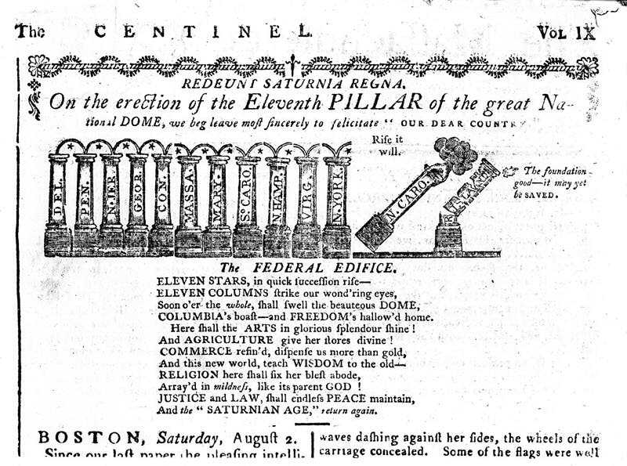

"Federal Pillar"
Massachusetts Centinel, (Boston) August 2, 1789
Newspaper
Document J

"We have had thirteen states independent for eleven years. There has been one rebellion. That comes to one rebellion in a century and a half for each state. What country before ever existed a century and a half without a rebellion?...

What signify a few lives lost in a century or two? The tree of liberty must be refreshed from time to time with the blood of patriots and tyrants. It is it's natural manure."

Thomas Jefferson to W. S. Smith on Shay’s Rebellion, 1787 Nov. 13.

