Module (8.2)
Pre-Assessment | Students will take the pre-assessment quiz for Module 8.2
Reading Activity | Students will use the documents below to compare the different agendas of Civil Rights leaders and how they would accomplish those goals. Students then need to compare and contrast to at least two other movements in US History.  - “Nonviolence: The Only Road to Freedom, May 4, 1966,” (excerpts)  - “The Ballot or the Bullet,” Malcolm X, April 3, 1964 (excerpts)  - Compare and Contrast Organizer
Writing Activity | 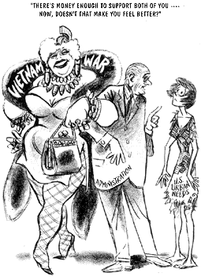http://ctah.binghamton.edu/student/lovell/herblock.gif  Describe the significance of this political cartoon as it relates to debates over social welfare programs.
Student Product | Students will choose one of the following Civil Rights movements: Native American, Latino, Women, African-American, Gay and Lesbian. Students should address major events such as protests, riots, Supreme Court Cases that impacted their chosen movement.  Students must create a full page (8.5x11) infographic. Here is a sample.  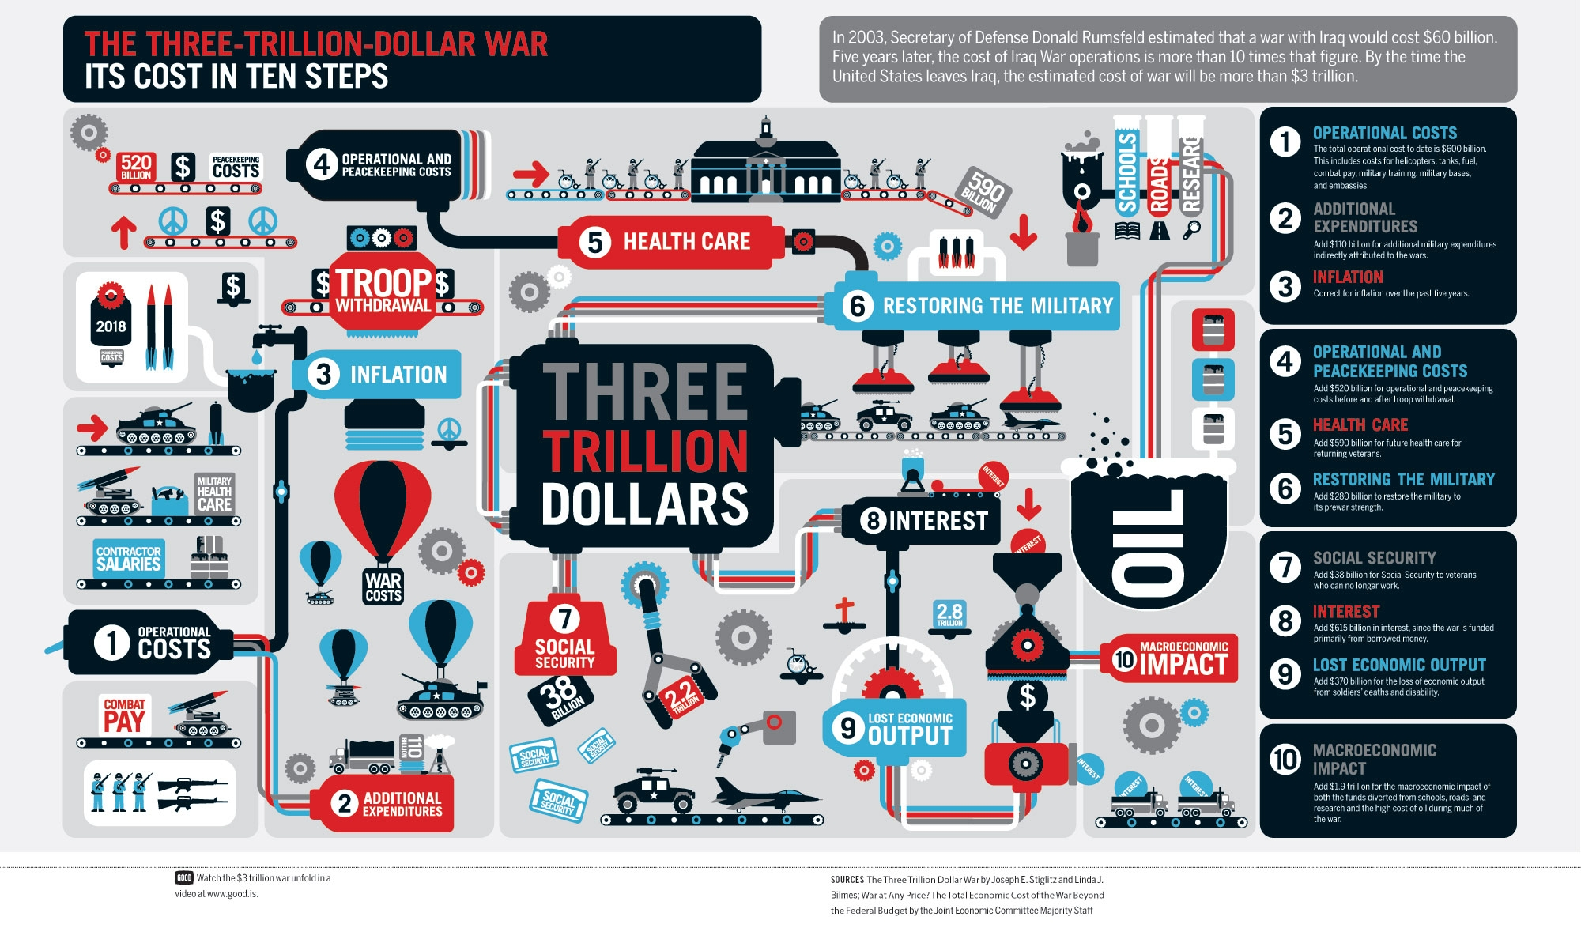  Students may use these options for creating their infographics.  http://piktochart.com/  https://www.canva.com/create/infographics/  https://venngage.com/

