Key Concept Formative Quiz 7.2

Refer to the early 20th century cigarette advertisement below:
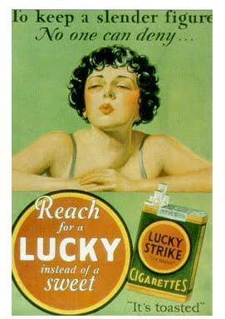

1. The ideas expressed in the above image most directly reflect what change in American culture since the mid-19th century?
- The increase in mass consumerism
- Changes in technology
- Conflict between fundamentalist Christian beliefs and modern science
- Changes in style and form of popular music

“In 1925 a trial in Tennessee threw into sharp relief the division between traditional values and modern secular culture. John Scopes, a teacher in a Tennessee public school was arrested for violating a state law that prohibited the teaching of Charles Darwin’s Theory of Evolution. HIs trial became a national sensation. The proceedings were even carried live on the radio.”
- From “Give me Liberty; an American History”

2. The Scopes trial was important because it highlighted the growing tensions between what major groups in american society?

- Christian fundamentalists and followers of modern science
- Republicans and Democrats
- School Teachers and Politicians
- Rural and Urban communities

“We admit that in many places and in ordinary times the defendants in saying all that was said in the circular would have been within their constitutional rights. But the character of every act depends upon the circumstances in which it is done...The question in every case is whether the words used are used in such circumstances and are of such a nature as to create a clear and present danger that they will bring about the substantive evils that Congress has a right to prevent.”
The majority opinion in Schenck v. U.S., 1917

3. The decision excerpted most directly reflected a belief that the power of the federal government should be used to:

a. limit freedoms during wartime
b. expand rights of the accused
c. curtail religious freedom
d. guarantee corporate contracts

“There is no place so lonely to a young man as a great city….when I walked along the street I scanned every face I met to see if I could perchance discover someone from Ohio. [Instead I saw a] sea of human units, each intent upon hurrying by….If it had been possible I would have gone back to Ohio, but I didn’t want to borrow the money, and I dreaded to confess defeat.” –Clarence Darrow

4. Darrow’s description of his visit to a large city is best, most specifically described by the term

- Alienation
- Cultural dislocation
- Isolation
- Homesickness

5. Which of the following caused the phenomenon described in the passage

- Strict government regulation of cities.
- The rapid pace of urbanization of the United States in the late 19th Century.
- The rise of agribusiness and corporate farming.
- The influx of immigrants into cities in the late 19th century.

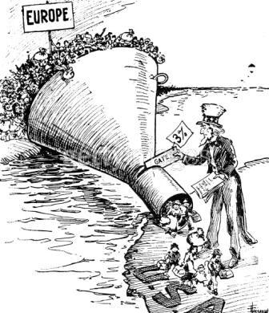
“The Only Way to Handle It,” May 19, 1921

6. What organization’s resurgence coincided directly with the influx of immigrants in the 1910s?
- The Ku Klux Klan.
- The Know Nothings
- The American Party
- Tammany Hall

7. The cartoon best represents continuity with what prior immigration legislation?

- The Gentleman’s Agreement of 1907.
- Comprehensive Immigration Act of 1899.
- Chinese Exclusion Act of 1882.
- Alien and Sedition Acts of 1798.

