Key Concept 5.1: The United States became more connected with the world as it pursued an expansionist foreign policy in the Western Hemisphere and emerged as the destination for many migrants from other countries.

Module 5.1

Pre-Assessment | Complete formative assessment quiz for 5.1
Reading Activity | http://h-net.msu.edu/cgi-bin/logbrowse.pl?trx=vx&list=h-labor&month=9507&week=b&msg=YgzOvTpisCgFKEjEfavFfg&user=&pw=  View “The Search for General Tso”, a documentary which journeys from Shanghai to New York to the American Midwest and beyond to uncover the origins of an iconic Chinese-American dish, while also exploring the Chinese immigrant experience.
Writing Activity | Question 1 is based on the following image and excerpt.  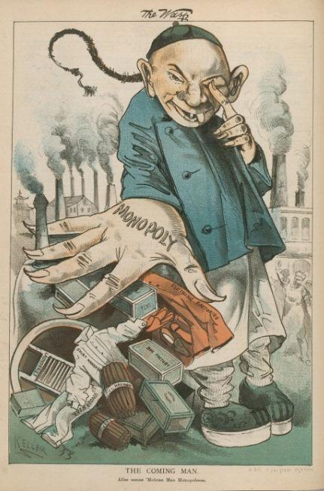  Cartoonist: George Frederick Keller  “Do not believe those who call us savages, rioters, incendiaries, and outlaws. We seek our ends calmly, rationally, at the ballot box. So far good order has marked all our proceedings. But, we know how false, how inhuman, our adversaries are. We know that if gold, is fraud, if force can defeat us, they will all be used. And we have resolved that they will not defeat us. We shall arm. We shall meet fraud and falsehood with defiance, and force with force, if need be.  We are men, and propose to live like men in this free land, without the contamination of slave labor, or die like men, if need be, in asserting the rights of our race, our country, and our families.  California must be all American or all Chinese. We are resolved that it shall be American, and are prepared to make it so. May we not rely upon your sympathy and assistance?  With great respect for the Workingman’s Party of California.  Dennis Kearney, President  H.L. Knight, Secretary  - Using the image and the excerpt, answer a, b, and c.  - Briefly explain ONE change in the second half of the 19th century that would have prompted Chinese immigration to the West.  - Briefly explain ONE major similarity in the concerns expressed over Chinese immigration by Dennis Kearney and George Frederick Keller.  - Discuss POV in the Kearney excerpt. Support your analysis with evidence from the document.
Student Product | Research U.S. policy on immigration and naturalization between the years 1844-1877. Use your findings to construct an illustrated timeline reflecting a minimum of five significant events/developments.

